
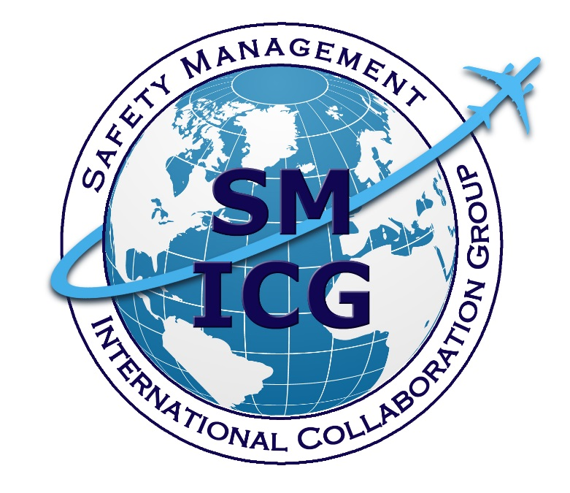
July 2019
Guidance for Comprehensive Safety Performance Management in a State Safety Programme
This paper was prepared by the Safety Management International Collaboration Group (SM ICG). The purpose of the SM ICG is to promote a common understanding of Safety Management System (SMS)/State Safety Program (SSP) principles and requirements, facilitating their application across the international aviation community. In this document, the term “organization” refers to a product or service provider, operator, business, and company, as well as aviation industry organizations; and the term “authority” refers to the regulator authority, Civil Aviation Authority (CAA), National Aviation Authority (NAA), and any other relevant government agency or entity with oversight responsibility.

The current core membership of the SM ICG includes the Aviation Safety and Security Agency (AESA) of Spain, the National Civil Aviation Agency (ANAC) of Brazil, the Civil Aviation Authority of the Netherlands (CAA NL), the Civil Aviation Authority of New Zealand (CAA NZ), the Civil Aviation Authority of Singapore (CAAS), Civil Aviation Department of Hong Kong (CAD HK), the Civil Aviation Safety Authority (CASA) of Australia, the Direction Générale de l'Aviation Civile (DGAC) in France, the Ente Nazionale per l'Aviazione Civile (ENAC) in Italy, the European Aviation Safety Agency (EASA), the Federal Office of Civil Aviation (FOCA) of Switzerland, the Finnish Transport Safety Agency (Trafi), the Irish Aviation Authority (IAA), Japan Civil Aviation Bureau (JCAB), the United States Federal Aviation Administration (FAA) Aviation Safety Organization, Transport Canada Civil Aviation (TCCA), United Arab Emirates General Civil Aviation Authority (UAE GCAA), and the Civil Aviation Authority of United Kingdom (UK CAA). Additionally, the International Civil Aviation Organization (ICAO) is an observer to this group.

Members of the SM ICG:
- Collaborate on common SMS/SSP topics of interest
- Share lessons learned
- Encourage the progression of a harmonized SMS/SSP
- Share products with the aviation community
- Collaborate with international organizations such as ICAO and civil aviation authorities that have implemented or are implementing SMS and SSP

For further information regarding the SM ICG please contact:
Claudio Trevisan Sean Borg Eugene Huang
EASA TCCA FAA, Aviation Safety
+49 221 89990 6019 (613) 990-5448 (202) 267-7577
claudio.trevisan@easa.europa.eu sean.borg@tc.gc.ca eugene.huang@faa.gov

Neverton Alves de Novais Ash McAlpine
ANAC CASA
+55 61 3314 4606 + 07 3144 7411
Neverton.Novais@anac.gov.br Ashley.Mcalpine@casa.gov.au

SM ICG products can be found on SKYbrary at: http://bit.ly/SMICG

To obtain an editable version of this document, contact smicg.share@gmail.com.

Table of Contents
1. Executive Summary 1
2. Definitions 2
3. Introduction 3
4. Overview of Safety Performance Management 4
4.1 Starting with a Clear Risk Picture 5
4.2 Establishing Safety Objectives 5
4.3 Measurement of System Risk 5
4.4 Determining the Acceptability of the State’s Level of Safety Performance 7
4.5 Management Actions 8
5. Risk Picture and State Safety Objectives 9
5.1 Developing a Risk Picture 9
5.2 Defining State Safety Objectives 16
6. Indicator Framework 17
6.1 Safety Performance Matrix and Tiers 17
6.2 Indicator Usage 19
6.3 Resource Requirements 20
7. Operational Risk Analysis 21
7.1 Designate Responsibilities and Establish Teams 21
7.2 Analyzing Operational Safety Issues 23
7.3 Determining Risk Controls or Actions 25
7.4 Defining SPIs and Their Specifications 27
7.5 Collecting Data and Reporting Results 28
8. Process Implementation Risk Analysis 29
8.1 Designate Responsibilities and Establish Teams 29
8.2 Analyzing Process Implementation Safety Issues 30
8.3 ICAO Annexes Implementation 30
8.4 Implementation of Safety Management Requirements 31
8.5 Determining Risk Controls or Actions 33
8.6 Defining SPIs and Their Specifications 34
9. Determining the State’s ALoSP 38
9.1 Determining the ALoSP to Be Achieved 38
9.2 Analyzing Information 39
9.3 Review Process 40
10. Management of Safety Performance 42
10.1 Monitoring and Communication 42
10.2 Continuous Improvement 42

1. Executive Summary
Safety management is crucial for managing risks in a complex, socio-technical environment such as aviation. The International Civil Aviation Organization (ICAO) requires States to manage risks at the State level through the implementation of State Safety Programs (SSP).
The main reason that a State implements an SSP is so that it can better manage aviation safety risks within its environment. Having a good understanding of its risks enables a State to take proactive actions to mitigate them and reduce the likelihood of those risks resulting in an accident or serious incident. A State would want to have good control and management of its safety performance.
As such, one of the key goals of the SSP is to achieve an Acceptable Level of Safety Performance (ALoSP). This document contains detailed guidance on the processes to achieve an ALoSP. This process starts with a State developing its risk picture; that is, forming a clear understanding of where the most significant risks are within its aviation system. The State then establishes clear safety objectives to focus its efforts on these most significant risks. The State sets indicators to monitor and measure those risks, and sets targets to bring them to within acceptable levels. The State would periodically review its performance against established objectives and determine if an acceptable level of safety performance has indeed been achieved. Mitigating measures may be adjusted and the safety objectives refined, as necessary. The risk picture itself will also change over time as existing risks are mitigated and new risks emerge. The cycle continues as the State improves on management of its aviation safety risks over time.

2. Definitions
These definitions are relevant to the development of Safety Performance Management (SPM) at the State level:

- Safety objective: brief, high-level statement of safety achievement or desired outcome to be accomplished by the State safety programme.

Note. – Safety objectives are developed from the risk picture of the State and should be taken into consideration during subsequent development of the Acceptable Level of Safety Performance (ALoSP) safety performance indicators and targets.

- Safety performance: A State or service provider’s safety achievement as defined by its safety performance targets and safety performance indicators (ICAO) Annex 19)

- Safety performance indicator: A data-based parameter used for monitoring and assessing safety performance (ICAO Annex 19)

- Safety performance target: The planned or intended objective for safety performance indicator(s) over a given period of time (ICAO Annex 19)

Additional definitions for safety management-related terminology is available in the Safety Management International Collaboration Group (SM ICG) Safety Management Terminology paper available at http://www.skybrary.aero/index.php/Safety_Management_Terminology.

3. Introduction
One of the main tenets of International Civil Aviation Organization (ICAO) Annex 19, Safety Management, is the concept of Acceptable Level of Safety Performance (ALoSP). Per ICAO Annex 19, ALoSP for the State can be demonstrated through State Safety Program (SSP) implementation and maintenance, as well as safety performance indicators and targets showing that safety is effectively managed and built on the foundation existing safety-related Standards and Recommended Practices (SARPs.) implementation.
This document provides guidance on risk and safety performance management to help States determine and manage the ALoSP. The scope of the safety performance management process described in this document covers all civil aviation activities within a State. It factors in the activities of the industry and the activities of the State as regulator and oversight authority.
This document is intended for ICAO Member States. States that have established an effective safety oversight system and have started implementing a safety management approach should consider developing their Safety Performance Management (SPM) framework. However, States that have not adequately implemented ICAO Standards related to safety oversight should first focus on improving their basic safety oversight capabilities.
There are 10 sections in this document. Sections 1 to 3 are introductory while Sections 4 to 10 illustrate the concepts of SPM.
Section 4 - Safety Performance Management Concept | Provides an overview of the SPM concept and framework.
Section 5 - Risk Picture and State Safety Objectives | Describes and discusses the importance of identifying key safety issues and establishing a risk picture. It also discusses setting safety objectives.
Section 6 - The Indicator Framework | Provides an overview of the SM ICG three-tier safety performance measurement framework.
Section 7 - Operational Risk | Describes a process that could be used to identify and analyze operational safety issues, determine risk control strategies and define associated SPIs.
Section 8 - Process Implementation Risk | Describes a process that could be used to identify and analyze process implementation safety issues related to the implementation of ICAO Standards, SSP and Safety Management System (SMS), and to determine risk control strategies and define associated Safety Performance Indicators (SPIs).
Section 9 - Determining the Acceptability of the State’s Safety Performance | Discusses how the State’ reviews its level of safety performance and the process to determine its acceptability.
Section 10 - Management of Safety Performance | Discusses the safety performance management topics such as various risk mitigation strategies, engaging management review, monitoring and communication, and continuous improvement.

4. Overview of Safety Performance Management
The absolute control of safety and zero accidents is desirable, but practically unachievable. While the elimination of aircraft accidents and/or serious incidents remains the ultimate goal, it is recognized that the aviation system cannot be completely free of hazards and associated risk. Since aviation is a complex system made up of multiple organizations and multiple human interactions operating in a global environment, the role of safety management is to manage risk within the aviation system to acceptable levels. The State establishes the acceptable level of safety performance to be achieved, or ALoSP in short.

This section introduces a model safety performance management framework for measuring safety performance, determining the ALoSP and assessing whether it has been achieved, and management actions to improve safety performance, as depicted in Figure 1, SPM Framework. Sections 5 to 10 present further details regarding each of these processes.

Figure 1: SPM Framework

4.1 Starting with a Clear Risk Picture
The first step in designing a State’s safety performance management framework is to develop a clear risk picture for the State. The risk picture reflects the State’s understanding of the most significant safety risks in its aviation system. Having a clear risk picture will allow for the subsequent establishment of clear safety objectives for the State.

The State should develop its risk picture based on an understanding of the dynamic nature of the aviation system. Risk in the aviation system is affected by many different factors, such as the size and complexity of the aviation system, the types of operation and how aviation safety responsibilities are organized within the State. By considering these factors, the State should be able to establish a reasonably accurate picture of the risks within its aviation environment.

4.2 Establishing Safety Objectives
Having a clear risk picture, and therefore a broad understanding of where key safety issues are, will support establishment of the State’s safety objectives. Safety objectives are brief, high-level statements of desired safety outcomes to be achieved by the SSP. They should be concise, overarching, and measurable. Safety objectives state, define, and provide direction for all relevant State agencies on the long-term goals regarding safety.

It is important, when defining safety objectives, to consider the State’s ability to implement subsequent activities that are necessary to achieve the safety objectives. The safety objectives provide a blueprint for directing the State’s resources. They represent the State priorities regarding the management of safety.

4.3 Measurement of System Risk
Measurements of safety performance at both the State and individual service provider levels are essential for effective safety management. It is also how the State assesses its performance with respect to its safety objectives. Traditionally, safety performance measurement has mainly been in terms of outcomes or events. From the perspective of safety management, however, assessment of safety performance should also include the measurement of system processes as they reflect how well the system is able to manage risks.

States measure safety performance through a set of safety indicators. These indicators should cover all aspects for which the State is responsible and reflect both outcomes (e.g., accidents, incidents, regulatory violations) as well as the proper functioning of system processes (i.e., the system performance). Figure 2, Measuring Safety Performance, shows how safety performance is determined by measuring the impact of safety management processes on the actual results achieved.

Outcome indicators
Process indicators
What results
What we do

Affected by
Measured by:
Safety performance
Figure 2: Measuring Safety Performance

The complex and highly coupled nature of global aviation can give rise to unexpected dependencies and latent conditions that, from experience, have been known to cause accidents. The best option for such a dynamic system is to monitor the system’s safety performance, in order to discover early on any potentially uncontrolled or unexpected dependencies. The State can make better decisions if it is aware of the correlations between safety outcomes and its own safety management processes. The two major types of risks that should be monitored and measured are termed operational risks and process implementation risks.

4.3.1 Operational Risks
Operational risk is focused on those conditions that could lead to an unwanted outcome (e.g., accidents, incidents, failures, defects). Operational risks are associated with service provision. Although States can monitor and establish a regulatory environment that seeks to reduce operational risks, they generally do not have direct control over these operational risks.

Some outcomes are more critical than others to the overall level of safety performance in a State. The State should prioritize the associated risk of those outcomes in order to identify key operational safety issues. For example, the State may want to focus on issues where there are systemic risks. The State should then assure adequate allocation of resources to manage the risks associated with each of these key operational safety issues.

A State should seek to understand the nature of each key operational safety issue —including the underlying hazards and possible consequences at all levels of the system— and of service provider and regulator behaviors. Some or all of this information may already be available from the initial risk identification process. There are many tools and approaches available to aid in this process, such as Bowtie analyses, event sequence diagrams, or fault tree analyses.

The key operational safety issues should be assessed through safety risk analysis in order to understand the actions necessary to mitigate the risk associated with each of them. These actions are then monitored using Safety Performance Indicators (SPI) in order to assess their effectiveness. Often, targets are set for an acceptable reduction of risk.

4.3.2 Process Implementation Risks
To provide a complete picture of safety performance, the means by which risk is managed should also be correlated to the actual safety outcomes experienced. Effective management of safety from a State perspective starts with evaluation of the effective implementation of: ICAO Standards and Recommended Practices, SMS implementation within the industry, and SSP implementation at the State level (which includes effective oversight of industry). The State can achieve this through analysis of ICAO Universal Safety Oversight Audit Program (USOAP) data, aggregation of SMS evaluations of the State’s service providers, and assessment of the SSP.

The evaluation of effective management of safety within the State should therefore include process implementation risks. Thus, safety performance measurement should involve assessing process implementation risk along with operational risk. The resulting actions to achieve necessary improvements with respect to these risks should then be planned, implemented and monitored, and adequate resources allocated. The risk of improper implementation has to be properly understood and managed. Monitoring is important in order to verify whether the processes are properly implemented, and if they contribute to the desired outcomes. Safety performance indicators should be developed that allow tracking of the planning, implementation, and effectiveness of the changes.

Improving performance with respect to operational risk tends to be more reactive, while improving performance with respect to process implementation risk tends to be more proactive. Improving processes should enable better identification and control of hazards before they manifest as operational risks. Furthermore, the areas for improvement should be prioritized according to what will provide the greatest safety benefit.

4.4 Determining the Acceptability of the State’s Level of Safety Performance
One of the principal reasons that a State establishes its SSP is to establish an acceptable level of safety performance in civil aviation system.

An ALoSP is a level of safety performance of the civil aviation system that a State is willing to accept. Implementation and maintenance of the SSP, meeting safety objectives showing that safety is effectively managed, and implementation of existing safety-related SARPs are elements of the ALoSP. The overall State safety performance is also dependent on the performance of its industry.

The State should periodically review its safety performance in order to determine whether it has achieved its ALoSP. A senior management team within the State usually does this. SPIs should inform the determination of whether a State’s safety performance is acceptable. Analysis of the State’s actual levels of safety performance against expectations set for each SPI, as well safety performance trends over time, will indicate whether or not the State has achieved its ALoSP.

4.5 Management Actions
A State measures safety performance in order to continually improve its management of risk in the aviation system. Following the determination of the State’s performance against its ALoSP, certain actions may be necessary to assure continual improvement.

These may include a decision to continue monitoring or a decision to change the monitoring program to collect additional information. If the objective associated with a certain SPI has been met, a State may decide that no further actions are needed and stop monitoring that SPI. Furthermore, when an SPI indicates subpar performance, it may be necessary to redesign the associated risk mitigations. Additional safety risk management (SRM) would then be performed to restructure the risk control.

In all cases, following the determination of acceptability, feedback to the risk picture is necessary. This should result in confirmation or modification of the risk picture. A modified risk picture may result in new or revised State safety objectives and hence new safety issues may need to be addressed.

The State should also communicate its safety performance to the State agencies that have a role in the SSP and to industry. When appropriate, that information can be made available to the public. This is true whether ALoSP has been achieved or not. Communicating positive results promotes a stronger safety culture. Communicating negative results reinforces accountability to make further improvements and can be an indication of a good safety culture.

The process described in Figure 1, SPM Framework, follows the traditional Plan-Do-Check-Act loop with the following components:
- Plan: Establish Risk Picture and State Safety Objectives (Section 5)
- Do: Manage Operational and Process Implementation Risks (Sections 6-8)
- Check: Determine of ALoSP through SPIs (Section 9)
- Act: Implement Management Actions (Section 10)

5. Risk Picture and State Safety Objectives
The purpose of safety performance management at the State level is to guide decisions related to resource allocation in order to improve safety performance. If safety is expressed in terms of controlling safety risks to an acceptable level, it follows that safety performance measures must relate to how well risks are being controlled by the responsible State agencies and service providers. Therefore, the State requires a clear understanding of the State safety risks and its own responsibilities and service provider responsibilities in managing those risks.

States should therefore base their system of safety performance management on a defined risk picture at the State level. The State takes into consideration constraints (e.g., resource availability, legislative imperatives, technological capability) and defines safety objectives which eventually provide the overall guidance for safety performance management.

5.1 Developing a Risk Picture

5.1.1 Identifying Safety Issues
As described in Section 4, a risk picture reflects the State’s understanding of the most significant safety risks in its aviation system.

When initially implementing its SSP, a State may not have yet established a coherent and comprehensive set of safety performance indicators that would provide it with a clear perspective of the safety risks within its system. A State can develop an initial risk picture using a combination of available quantitative and qualitative data, in conjunction with the judgement of selected aviation experts. This can be done through focus groups with the available data on hand. Such a brainstorming approach should be done collaboratively with service providers, which will enable the State to identify ‘known’ safety issues for each aviation sector.

As much as possible, expert opinion should be informed by available quantitative and/or qualitative safety data. In order to avoid judgments that cannot be substantiated, the expertise of people involved in establishment of the initial risk picture should be based on data analysis that they have access to (e.g., organizations’ SMS data) or their own extensive experience working in the sector (e.g., highly experienced commercial pilot, air traffic controllers, aeronautical engineers).

In gathering expert judgement, States should have good representation from all relevant stakeholders. This means that experts from industry should be drawn from both management as well as front line employees. Different experts from the regulatory authority should also be included in order to have different perspectives. Experts would bring their own respective perspectives, for example:
- Industry experts have knowledge of safety data, safety issues, analysis of these issues, and deficiencies of barriers at the level of an organization within their sector. They will have more precise knowledge of specific safety issues but are usually limited to the range of their operations.
- State experts are involved in the analysis of safety data (e.g., mandatory and voluntary occurrence reports, safety performance indicators, accidents/incidents reports) as well as oversight of the industry. They are likely to have broad knowledge about safety issues at the sector level.

The State should have an established review process in order to avoid failing to identify an important safety issue when establishing the initial risk picture. This process should be designed so that the expert group reviews all aspects of the aviation system. The review should consider at least the following aspects:

- Safety outcomes, which could be reviewed by accident/incident type such as:
  - Controlled Flight Into Terrain (CFIT)
  - Loss of Control Inflight (LOC-I)
  - Ground collision
  - Mid-air collision
  - Runway incursion and excursion
- Industry performance, for example with respect to the level of regulatory compliance and the level of SMS implementation. States and industry organizations can use the SM ICG SMS Evaluation tool to review all relevant performance aspects of SMS.
http://www.aviationsafetywiki.org/index.php/SM_ICG_SMS_Evaluation_Tool
- State performance, for example with respect to the level of compliance with international Standards and the level of SSP implementation. States can use the SM ICG SSP Assessment tool to review all relevant performance aspects of SSP http://www.aviationsafetywiki.org/index.php/SSP Assessment Tool.

When considering the aspects discussed above, States should keep in mind that safety risks in the aviation system are affected by many different factors. The following factors should therefore also be taken into consideration when developing the risk picture:

- Size of the aviation system (e.g., number of airlines, number of aircraft, number of flights in and out of the State, number of airports, number of maintenance organizations, number of Air Navigation Service Providers (ANSP), size of airspace,) and anticipated changes in the size of the aviation system.
- Complexity of the aviation system (e.g., one main big airline or many small ones, scope of general aviation activities, one single airport operator or different ones, whether service providers are managed by the State or not, range of maintenance activities) and anticipated changes in the complexity of the aviation system
- Types of operation (e.g., commercial, general aviation, domestic, international)
- How the aviation safety responsibilities are achieved (e.g., how regulations are implemented, how oversight is carried out)
- The organization of the aviation safety responsibilities in the State and the relationship between them (relationship between those responsible for accident investigation and the regulator, multiple agencies responsible for regulation/oversight in a State)
  - Aviation safety activities delegated to other entities
  - Participation in Regional Safety Oversight Organizations
  - Amount of military aviation activity in the State

5.1.2 Sources of Safety Data/Information
There are a number of sources of safety data/information available to the State. Typically, most safety risk data come from event data, either data from accidents or incidents collected through reporting systems and from safety oversight or other audits and inspections. The utilization of data sources is based on a number of factors, including availability, completeness, reliability and validity, and the objectives of the analysis.

Accident data are generally the most complete in terms of having a comprehensive list of occurrences. Because of investments in fact-finding and analysis related to accidents, they tend to be the richest source of information on factors involved. However, because they are based on past occurrences, these analyses are also the most reactive. Incident data are the next most complete data source. However, unlike accident data, many occurrences may not be reported, recorded, or even observed. Analyses of incident data will also require further, often subjective analysis to identify contributing factors and their potential to progress to an accident.

Accident and incident investigations can provide valuable information on factors related to accident causation. Aggregating data from the investigations of similar events can also lead to the identification of safety deficiencies that may be present in other operational conditions. Conditions or combinations of conditions that are obvious after the fact may not be evident beforehand. At the same time, factors that were present at the time of an accident may be benign in alternative combinations. Effective analysis of all this data can provide valuable insight in predicting the likelihood of recurrence.

Aviation safety risks within a State can be similar to the aviation safety risks in other States. For example, a State that has one commercial airline could supplement its own data with pertinent information from other States that have similar operations. The State could also make use of information from other sources (e.g., ICAO Global Aviation Safety Plan, Regional Aviation Safety Groups, International Aviation Transport Association) in the development of its risk picture.

Some safety risk analyses also include data/information that may come from sources such as mandatory and voluntary safety reporting systems, employee reporting systems, safety oversight audits findings, surveys, economic and financial information, safety performance indicators, and safety-related feedback.

When considering actual events such as low-severity occurrences, hazards, regulatory violations, etc. the analysis must look two ways: backward, to see what factors could have affected human or other system performance to result in an error; and forward, to evaluate possible outcomes from future events under similar conditions.

Data on low-severity occurrences and hazards is subject to limitations on completeness, particularly in the case of voluntary reports. Many occurrences may not be reported, recorded, or even observed. These data sets reflect at best the minimum that have occurred. Mandatory and voluntary reports may be sensitive to reporting bias and further investigation of such reports may gather more accurate information. In addition, voluntary reporting may be hampered by fear of repercussions or social pressures; individuals may be reluctant to report errors even when policies support reporting. Reporting policy and organizational cultures should therefore be carefully cultivated to encourage reporting.

To complement incident and hazard data, observations, audits, and oversight data can be used to assist in assessing safety performance. By using standardized audit processes and taxonomies, the State can collect valuable information for development of its risk picture. Internal audits can also provide knowledge about safety issues linked to the organization. The State can use specific tools, such as the SMS Evaluation Tool and SSP Assessment Tool to assess the maturity of the system.

Data on State implementation of ICAO SARPs, SMS implementation by industry, and State implementation of SSP should also be used to build the risk picture. The levels of implementation can be an indication of State’s ability to manage its aviation system.

States can also use predictive safety risk analyses, which seek to anticipate future outcomes based on currently available data. Such analyses are normally used to identify safety deficiencies that could result in unwanted outcomes associated with the introduction of a new system (product or service), process, procedure, or functional change. They are typically used to analyze the impact of changes that would be made to a system or process for reasons other than to correct safety deficiencies.

In some cases, data may not be readily available because the system as envisioned has not yet been implemented or operated. In other words, no events would have occurred, no safety audits or inspections would have been conducted, and employees would not have submitted safety reports. In that case, predictive safety risk analysis will rely on sources of data/information such as Preliminary Hazard Analysis (PHA) of future systems or proposed changes and will take advantage of the potential of data analysis of service providers (e.g., airlines Flight Data Analysis, air traffic radar information).

Further information on data attributes can be found in the SM ICG Risk-Based Decision Making Principles Document at http://www.aviationsafetywiki.org/index.php/Risk_Based_Decsion Making_Principles.

5.1.3 Prioritizing the Safety Issues
The significance of safety issues stems from their potential consequences, such as:

- Fatalities and injuries resulting from the functioning of the aviation system;
- Damaged or destroyed aircraft; and
- Loss of reputation.

Thus, each State must analyze its data to identify safety issues, and then examine the safety issues of concern for safety risk management purposes. Since resources are limited, their allocation should take into account relevant constraints, such as economic, technical, legal, and political constraints. Once the State has identified all safety issues, it should prioritize them in order to identify the key ones. The priority should be assessed based on the analysis of safety issues using available data and tools (see Section 7 and 8 for more details on safety issue analysis).

The following types of safety issues should be of primary concern in the prioritization process:

- Operational safety issues with high probability and/or high severity
- Operational safety issues with increasing risk level in recent years
- Systemic safety issues
- Emerging safety issues

For prioritization of process-related safety issues, the State should make every effort to consider the effectiveness and the criticality of the process. In prioritizing the safety issues, the experts involved should distil the list down to the key safety issues that the State should focus on. This does not mean that all other safety issues are unimportant and do not need to be dealt with; rather, prioritization allows the State to focus its resources on addressing those safety issues that have the most potential to improve its safety performance.

5.1.4 Representing the Risk Picture
Key safety issues identified from the prioritization process make up the State risk picture. The initial risk picture could take various forms ranging from a simple list of safety issues to a set of bow ties or risk maps describing the safety issues. A mention of the known causal factors can also help provide clarity in the risk picture.

The safety issues could also be numbered or colored based on the level of risk posed, as shown in Figure 3, Severity and Likelihood Matrix. In using this methodology, those safety issue issues that tend towards the “unacceptable” part of the matrix would be prioritized.
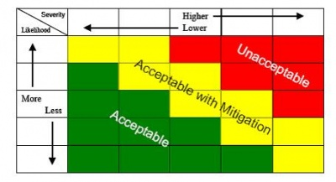
3
21
1
1
Figure 3: Sample Severity and Likelihood Matrix

Table 1, Sample Risk Picture, shows a sample basic and fictitious risk picture in tabular form.

Table 1: Sample Risk Picture
Operational Safety Issues (Air Operator)
Safety Issue | Potential Causal Factors | Risk Level
Use of erroneous parameters at take-off | Flight crew error during data insertion, loading crew error, etc. | 1
Adverse environmental conditions mismanagement | Incorrect use of meteorological radar, lack of upset detection and recovery training, etc. | 2
Fire in flight | Lithium Batteries, etc. | 1
... | ... | ...
Operational Safety Issues (Aerodrome)
Safety Issue | Potential Causal Factors | Risk Level
… | …
Process Safety Issues (for Industry)
Safety Issue | Potential Causal Factors |  | Risk Level
Poor safety culture | Fear of sanctions, overconfidence, etc. | 2
Change mismanagement | Lack of anticipation, no defined responsibilities, etc. | 2
Interfaces mismanagement | Insufficient communication, etc. | 2
... | ... | ...
Process Safety Issues (for the State)
Safety Issue | Potential Causal Factors | Risk Level
Lack of expertise | Insufficient training, inadequate recruitment, etc. | 1
High turnover rate | Lack of resources, unattractive offices location, etc. | 2
Inadequate level of compliance with ICAO SARPs | … | 2

5.1.5 Updating the Risk Picture
The State should review the risk picture periodically using expert judgement and data analysis in order to identify safety trends and emerging safety issues. As a State gains more experience in selecting, monitoring, and analyzing its SPIs, it may start to rely more on quantitative data in order to inform its decisions on updating the risk picture. However, it is still important to involve experts in the process since there may be emerging risks that are not tracked quantitatively. The judgements of experts who may be informed by broader trends in the aviation system will continue to be relevant and useful. In order to avoid failing to sufficiently prioritize an important safety risk when updating the safety risk picture, States should use the review process defined according to Section 5.1.1.

5.2 Defining State Safety Objectives
There is an important link between the risk picture as discussed in the previous sections, and the State safety objectives discussed in this section. To a large extent, safety objectives define and communicate underlying State values regarding safety in aviation operations and the operational environment. The establishment of safety objectives should take into account the State’s knowledge of its key risks acquired through the risk picture exercise.

A safety objective is a brief, high-level statement of safety achievements or desired outcomes to be accomplished by the State’s SSP or service provider’s SMS. Safety objectives should be general, concise and overarching; yet, they must convey an understanding of the potential activities that are necessary to achieve the desired safety performance. The purpose of setting State safety objectives is to identify what should be achieved by the State in the coming years as related to civil aviation safety. Safety objectives may be used not only to focus efforts on improving safety in key risk areas, but could also be used to focus on maintaining current safety performance in other areas that the State deems to be critical.

Safety objectives may be process-oriented (i.e., stated in terms of safe behaviors expected from operational personnel or of safety interventions implemented by the State or industry). Safety objectives may also be outcome-oriented (i.e., actions and trends regarding containment of accidents or operational losses). The State should define both types of safety objectives. A State should work towards its safety objectives by putting in place risk controls and measuring their impact using safety performance indicators. This will be discussed in further detail in Sections 7, 8 and 9. Table 2, Sample Safety Objectives, provides an example of a set of safety objectives.

Table 2: Sample Safety Objectives
Objective 1: Reduce the number of incidents related to commercial aviation by 15% by 2021
Objective 2: Enhance the industry’s safety culture
Objective 3: Improve level of compliance with ICAO SARPs
…

6. Indicator Framework
A safety performance indicator (SPI) per ICAO Annex 19 is a “data-based parameter used for monitoring and assessing safety performance.” SPIs must be simple, measurable, and reliable. Indicators of performance should consist of both outcome indicators and process indicators as discussed in Sections 7 and 8.

Outcome indicators focus on the direct results and ultimate benefits of safety management processes. In other words, they measure how operational risks are being managed. Process indicators focus on the functioning of safety management processes. In other words, they measure how process implementation risks are being managed.

6.1 Safety Performance Matrix and Tiers
The SM ICG developed Figure 4, SM ICG Safety Performance Measurement Matrix, below. It provides a useful framework to assist in SPI development. The matrix is composed of three tiers, which describe the different levels of aviation system performance, and three pillars, which describe the way safety is measured and managed.

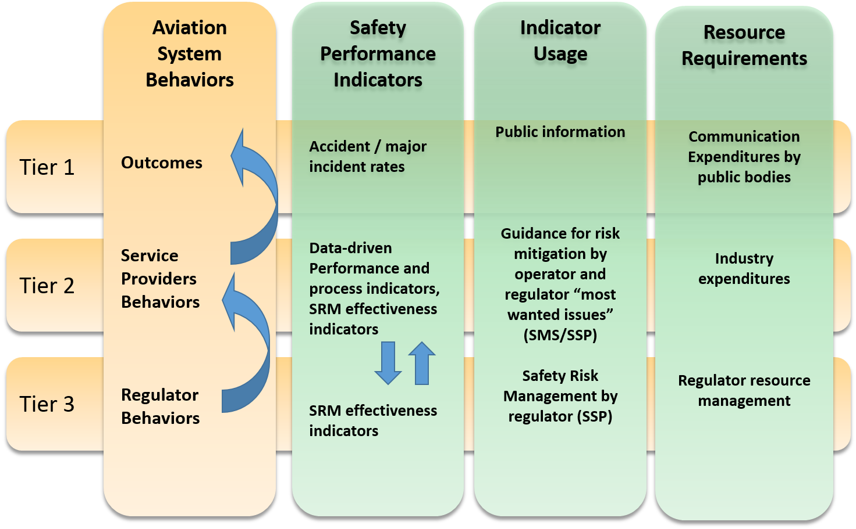
Figure 4: SM ICG Safety Performance Measurement Matrix

Tier 1 looks at the overall system performance in terms of safety outcomes.
Tier 2 concentrates on the service provider’s performance.
Tier 3 concentrates on the regulator performance.

The three tiers interact vertically as the regulator’s performance affects the service providers’ behaviors, which will in turn have an effect on the overall level of safety. Figure 4 also shows how the system performance is measured at each tier (SPIs), how the indicators are used (indicator usage” and what resource requirements are attached to measuring safety at each of the tiers.

6.1.1 Tier 1
Tier 1 looks at the overall system performance in terms of safety outcomes. The SPIs at Tier 1 (outcome indicators) can be largely harmonized across States and regions and can thus be easily defined. SPIs at tiers 2 and 3 will be region-specific and depend on the regional or national situation and the SSP implementation for the respective State.

Some Tier 1 SPIs, like fatal accident rates, are well suited for long term trending and factor analysis applied to strategic planning. However, they States should use them carefully for safety performance measurement of individual service providers or for short-term trending, due to the low frequency of these events and consequent large variations.

Tier 1 outcomes, in most cases, stem from the interactions of different service providers in a multitude of combinations. For example, a fatal accident may simultaneously involve factors associated with a manufacturer, a maintenance provider, and a training provider. An SPI derived from such inherently aggregated outcomes may not be appropriate for any individual provider. Any service provider-level SPI that is based on Tier 1 SPIs must be carefully considered to ensure appropriateness.

Incident data is another important potential source of Tier 1 SPIs. However, in order to use incident data in predictive measures, States must correlate it with the causal chain leading to fatal accidents. It is now widely accepted that many types of typical low-level events (e.g., ground damage, in-flight turbulence injuries) may not adequately predict the occurrence of fatal accidents. Causes of minor incidents may not correlate highly with causes of more serious events unless underlying causes are analyzed thoroughly. This underscores the need to use additional data from additional sources, such as employee safety reporting and flight data analysis programs.

6.1.2 Tier 2
Tier 2 concentrates on the service provider’s performance and Tier 2 SPIs address the behavior of aviation service providers. The SPIs in this tier fall into four different types:

- Data-driven performance and process SPIs take Tier 1 SPIs as a starting point, but are developed further down the causal chain from the main outcomes. The approach aims to identify the main accident scenarios and related safety issues to identify targets for risk management.
- Scenario-based SPIs identify hazards derived from potential accident scenarios and apply them to development of SPIs where no accident or major incident has ever happened. These affect both Tiers 2 and 3.
- SPIs measuring the effectiveness of safety risk mitigations at the service provider level. Examples of this approach are implementation of Commercial Aviation Safety Team (CAST), Aviation Safety Information Analysis and Sharing (ASIAS) and European Strategic Safety Initiative (ESSI) recommendations.
- Process-based SPIs measuring the effectiveness of safety management processes— that is, the capability of a service provider to manage safety risk.

Tier 1 and 2 SPIs are appropriate when sufficiently detailed data about accident/incident scenarios exists, such as data on individual operational actions/decisions or whether data on specific operational personnel met established qualification/training requirements. However, for certain service providers such as design or manufacturing organizations, this kind of data does not exist or is limited. For these service providers, safety performance is closely related to assuring correct and effective operation of processes, such as those used to design and certify a product or to perform safety risk management of organization-level changes. For these service providers, the State should understand service provider behavior in terms of the manner in which the service provider goes about exercising its safety management processes.

6.1.3 Tier 3:
Tier 3 concentrates on the regulator performance. Tier 3 SPIs look at the effectiveness of the mitigation measures put in place by the regulator. Tier 3 SPIs measure how well safety initiatives of the regulator achieve their desired objectives. Safety outcomes and service provider behavior all reflect on the regulator. Moving up the chain, effective regulator activities should motivate service provider behaviors that, in the aggregate, result in overall improvements in safety outcomes. The State could also monitor implementation and effectiveness of its own organizational and process risks as Tier 3 indicators.

6.2 Indicator Usage
The pillar Indicator Usage defines what the SPIs in the three tiers will be used for. The actual usage can then inform and drive the discussion on how the SPIs have to be formulated.

SPIs at Tier 1 are largely for strategic planning and public information. They describe the overall outcome of the system, which is the main concern for the public.

SPIs at Tier 2 are used to guide service providers and regulators in their actions to mitigate safety risk as part of their SMS/SSP. Thus, they also have an impact on resource allocation.

SPIs at Tier 3 provide States with feedback on the performance of their SSP, which can guide ongoing and future decision making. They also support processes to measure and monitor the safety performance of the SSP.

6.3 Resource Requirements
At each level, the regulator or the service provider allocate resources in order to manage safety. The pillar Resource Requirements addresses resource allocation and prioritization relative to their influence on the safety behavior and performance at each tier.

States are encouraged to make use of Figure 4, SM ICG Safety Performance Measurement Matrix, in developing their SPIs in order to monitor operational risks and process implementation risks.

7. Operational Risk Analysis
The risk picture (see Section 4) will be the starting point for identifying safety issues that should be the target of safety risk management. From the risk picture, the State can identify areas that are significant to overall aviation system safety. These are termed safety issues and fall into two categories: operational safety issues and process implementation issues. Figure 5, Operational Risks, below shows how data analysis and modelling of safety issues allow for prioritization of risk control strategies and for the development of assurance activities, including defining SPIs.

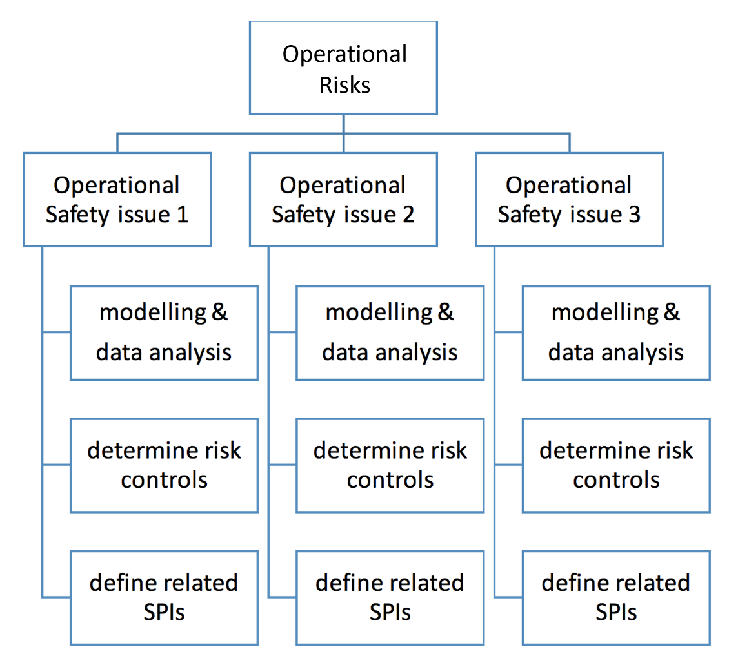
Figure 5: Operational Risks
Operational safety issues could either be defined in terms of operational risks (e.g., aircraft upset in flight) or aspects related to the operating environment (e.g., helicopter off-shore operations). Sections 7.1 to 7.5 provide a process that could be applied to analyze operational safety issues, determine risk control strategies and define associated SPIs.

7.1 Designate Responsibilities and Establish Teams
In order to identify meaningful risk controls or actions and related SPIs, management must be fully committed to implementing actions and identifying related accountabilities and responsibilities. A fundamental part of the State safety management approach is management commitment; it is critical.
Once the State has defined accountabilities/responsibilities, the next step will be to designate a team with responsibilities for:

- Initiating effective promotion and coordinated introduction of operational safety issues;
- Ensuring coordination between different State departments or divisions; and
- Overseeing the implementation.

The team should include or have access to subject matter experts. Since the team will evaluate information from various departments, at least one knowledgeable expert from each department would be required on the team. Cross-department representation is essential as there is a high probability that an undesired outcome reported by one sector will have relationships to causal and contributing factors and/or risk control actions by one or more of the other sectors. Thus, experts familiar with each sector can help identify causal and contributing factors for the analysis of safety issues.

On the other hand, when assembling the team, too many members may complicate or slow the process. The team should strike an efficient balance of members and expertise to ensure that analysis can be done in a reasonable amount of time.

In selecting team members, States should consider:

- General knowledge of the State’s aviation system;
- Detailed knowledge (technical or managerial expertise) of one or more industry sectors within the State;
- Objectivity sufficient to consider risk outside of their responsibilities;
- Ability to consider risk at a sector and system level; and
- Knowledge of risk management and experience in various hazard analysis techniques.

Also, it is essential that department managers for different sectors take ownership of safety performance management for their respective areas. This team must clearly be shown to be in either a support or advisory role to senior management and department managers. The team should set a reasonable timetable, including milestones, to ensure adequate progress.

Senior management should be kept informed of progress on a regular basis and should take an active role in steering the process of implementing actions and achievement of SPIs. For larger States, it may be useful to develop an analysis of the costs and benefits of the development project, with particular focus on State’s “management information system” that will lead to improved resource allocation.

Note: some risk controls may need to be implemented by industry. In those cases, close collaboration and commitment both from the State and the industry will be required to ensure successful implementation of agreed upon risk controls.

7.2 Analyzing Operational Safety Issues
In the next step, the team should analyze each operational safety issue to understand the nature of the associated risks. This analysis should allow for identification of hazards and causal and contributing factors; include a systemic view; consider organizational and operational environment aspects; and consider the effectiveness of existing controls (both preventive and recovery controls).

Analyzing operational safety issues normally entails both qualitative and quantitative data (e.g., occurrence reports, event rates, radar tracks, hardware failure rates) and may require some form of modelling of causal/contributing factors, unsafe operational states, and unwanted outcomes. The team can use a number of modelling techniques, depending on the safety issue and data sources available (e.g., Bowtie, graphical system/process descriptions, flowcharts, hierarchical control structures).

Table 3, Sample Operational Safety Issue, shows the use of erroneous parameters at take-off as a sample operational safety issue with specifying detail. The following resources contain further information on modelling techniques:

- SKYbrary Safety methods and tools:
http://www.skybrary.aero/index.php/Category:SM_Methods_and_Tools
- UK Civil Aviation Authority (CAA) bow-tie tool box:
https://www.caa.co.uk/Safety-initiatives-and-resources/Working-with-industry/Bowtie
- MIT Systems Theoretic Accident Model and Processes – Systems Theoretic Process Analysis:
http://psas.scripts.mit.edu/home/home/stpa-primer/

Table 3: Sample Operational Safety Issue
Example of an Operational Safety Issue
Use of erroneous parameters at take-off
Sector
Commercial air transport – fixed wing

Figure 6, Take-off with Erroneous Parameters Bow Tie, depicts this operational safety issue.
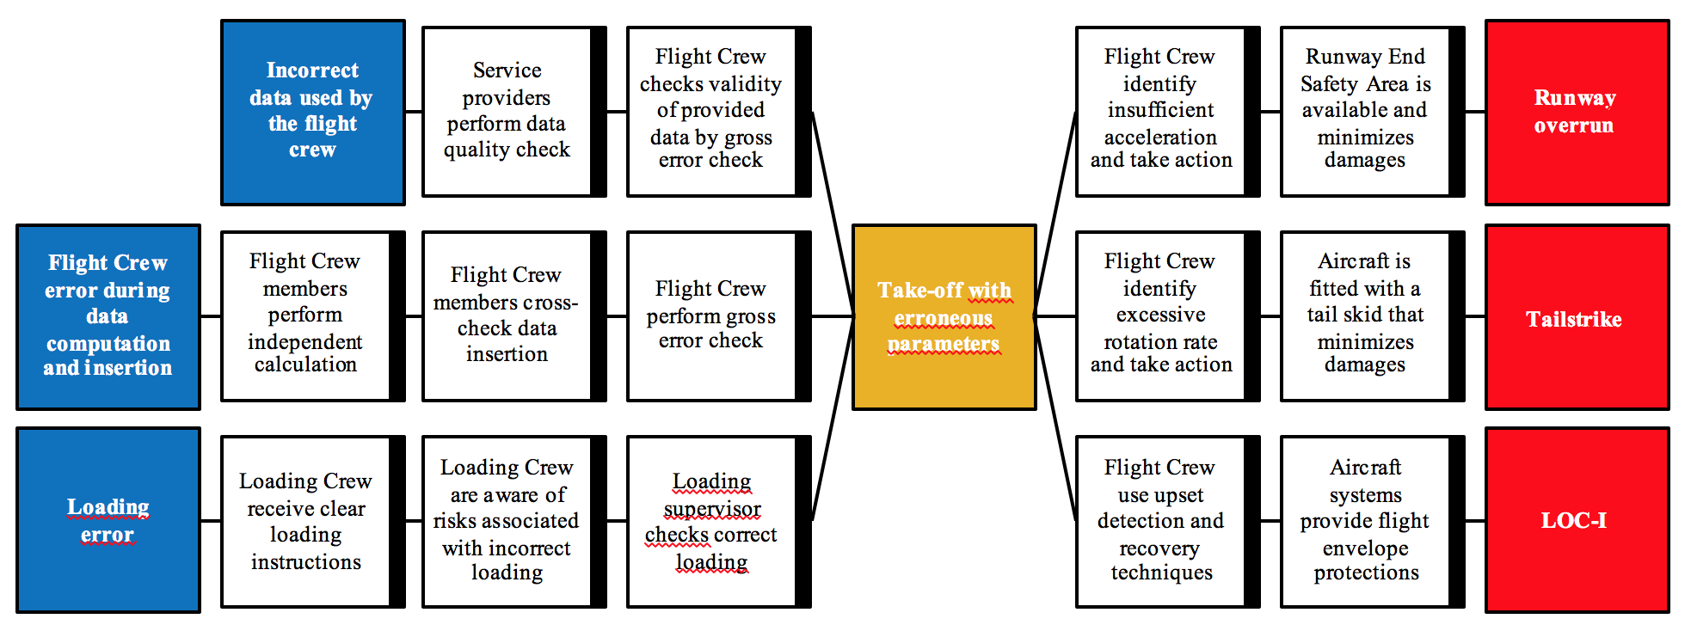
Figure 6: Take-off with Erroneous Parameters Bow Tie
Using quantitative data for the analysis is often preferred, as it is usually considered to be more objective. However, the team should use caution for the following reasons:

- The source of quantitative data may not be reliable (e.g., reporting data is subject to reporting biases).
- Quantitative data may originally be derived from qualitative data and standardized by means of common taxonomies, so its accuracy cannot be guaranteed.
- Event based data (e.g., counts of lower level incidents) may have low predictive validity for accident risk.
- Adequate data may not exist, which may result skewing the analysis.

In addition, historical data may not properly represent future operating environments. Meanwhile, qualitative data also has its limitations. In particular, data that is based on judgement may vary from person to person. If only one person is performing the analysis, then a peer review of results can increase their reliability. In essence, safety issue analysis using a combination of qualitative and quantitative data will largely rely on the background of experts on the selected team and their understanding of the system or process being analyzed. The SM ICG Risk Based Decision Making document has further information on data attributes for effective safety risk analysis.

The team can collect safety data and information for operational safety issue analysis through internal and external sources, or a combination of both. Typical sources of safety data and information include, but are not limited to:

- Civil Aviation Authority (CAA) auditing information,
- Information obtained through agreements with industry,
- Information obtained through regional or global agreements,
- Information gathered through voluntary reporting systems,
- Accident or incident reports,
- Flight Safety Foundation reports,
- ICAO reports
- CAA Quality Management System (QMS) data,
- Other CAA reports,
- Industry association reports, and
- Flight Data Monitoring (FDM) data, if available.

Some or all of this information may already be available from the initial process to develop the State risk picture. These same sources will likely be used in monitoring performance associated with each safety issue. Furthermore, an important step in any risk analysis is the documentation of various assumptions that lead to a specific risk classification. These can then be revisited in the future and updated when necessary, especially if the operational environment changes. Note that States should strive to identify operational safety issues that are systemic rather only a single occurrence.

7.3 Determining Risk Controls or Actions
Once the team has analyzed safety issues, it will need to consider various options to control the risks. For operational risks, this should be done through a collaborative approach that engages both the subject matter experts within the State and relevant industry organizations. The determination of risk controls should be based on the causal factors identified and the capability and capacity to implement. Risk control selection should consider any or a combination of the following strategies:

- Risk Avoidance Strategy: This is the decision not to operate or take a completely different approach. This strategy is more likely used as the basis for a “go” or “no-go” decision at the start of an operation or program.
- Risk Reduction Strategy: This means a reduction of frequency of operation or activity, or an adoption of specific actions to reduce the severity of the consequences of the accepted risks. This strategy can lead to a risk transfer action if the specific actions to reduce the risk are controlled by another party.
- Risk Transfer Strategy: This shifts the ownership of risk to another party. This is not always the best option as the risk remains but it may have been transferred where there is less control.
- Segregation of Risk Exposure Strategy: In this strategy, action is taken to isolate the effects of risks or build in redundancy to protect against them. An example of segregation of exposure is to limit operation into an aerodrome surrounded by complex geography to aircraft with specific navigation capabilities.
- Risk Acceptance Strategy: This is simply accepting the likelihood and the severity of consequences associated with a risk’s occurrence. This strategy is not recommended for high risk associated with a hazard. The safety risk should still be mitigated to reduce it to lower levels before it can be accepted.

Risk controls usually aim at a change in organizational behavior, individual behavior, or conditions. When determining which option will be best, the team should consider the following questions:

- How likely is it that the risk control strategy will be accepted by the industry and internal stakeholders in the State?
- How costly is the risk control strategy likely to be? Answering this question might require an impact assessment.
- Will the risk control strategy create new risks or exacerbate or influence existing strategies?
- How difficult will the risk control strategy be to implement? How much time will take?

The potential actions that could be used to control a safety issue by the State can be broken down into four main categories of action, in which further decision making is necessary to select the best risk control options. They are:

- Rulemaking,
- Enforcement of the existing rules,
- Oversight focus, and
- Promotion of best practices (through working with the industry, safety communications).

The team should use subject matter expertise to judge which options are most likely to control the risk; it should also consider industry input.

Table 4, Sample Risk Controls, shows potential actions for use of erroneous parameters at take-off.

Table 4: Sample Risk Controls
Example Operational Safety Issue
Use of erroneous parameters at take-off
Risk Controls
RC.01 Launching a rulemaking activity on the use of Electronic Flight Bags
RC.02 Focusing oversight on the procedures for data insertion in the Flight Management System (FMS) and Electronic Flight Bag (EFB)
RC.03 Promoting best practices such as gross error check
RC.04 Promoting the development of FDM analysis for such events (e.g., through dedicated working groups)
RC.05 Promoting the consideration of this issue in operators and flight training organizations’ SMS

As it is often neither possible to implement all of these control actions, nor to implement them at the same time, the team should prioritize its actions. The team can prioritize by determining the associated implementation costs versus expected safety benefits, and/or using established regulatory impact assessment protocols, while considering any interdependencies. This exercise will also help determine the best sequence of actions. For example, launching RC01 may benefit from feedback received following the implementation of RC02 and RC03. Finally, it is important that methods used to prioritize risk controls are consistently used for the analysis of all operational safety issues

7.4 Defining SPIs and Their Specifications

7.4.1 SPIs Scope and Focus
Once the controls have been determined, the team can define SPIs, taking into account the context established through the earlier steps. Whenever possible, SPIs should be chosen based on their relevance rather than the availability of data to measure them to ensure that measures are appropriate. Choosing indicators based on data availability is likely to result in SPIs that are easy to measure, rather than SPIs that are most valuable for effective safety management.

It is important to both measure the actual risk reduction (e.g., fewer events per flight hour), and to identify the activities and processes performed to achieve that reduction. Doing both will indicate some level of correlation between the efforts of the State and service providers to the achieved level of risk reduction in the aviation system. For each safety issue and associated risk controls, SPIs will serve three purposes:

- Monitor the effects of risk controls on outcomes (Tier 1);
- Measure service provider’s ability to manage an identified safety issue (Tier 2); and
- Measure the State’s ability to put effective risk controls in place (Tier 3).

Depending on the safety issue, one or more SPIs can be defined in order to achieve specific objectives. In the example of the safety issue “use of erroneous parameters at take-off,” the team could define the following SPIs that are related to the action taken:

- Number of incidents detected by dedicated Flight Data Analysis (FDA) systems (target: decreasing trend).
- Number of participants in the FDA working groups (target: increasing trend).
- Difference between the scheduled and achieved publication date of the regulation on Electronic Flight Bags (target: less than three months).

Note that the first indicator above can be used as a Tier 1 and Tier 2 SPI. The second indicator can be used as a Tier 2 and Tier 3 SPI. Finally, the third indicator can be used as a Tier 3 SPI.

7.4.2 SPIs Specifications
To be meaningful, both qualitative and quantitative SPIs must be based on reliable and valid data. Data quality principles and practices should be applied throughout the processes from data capture and integration to analysis. Guidance about required data attributes and data management can be found in SM ICG Risk Based Decision Making document.

Once the scope and focus of the SPIs have been determined and available data/information reviewed, the specifics need to be defined. Each SPI should be accompanied by sufficient information that enables any user to determine both the source and quality of the information, and understand what is showing.

When specifying an SPI, the team should consider the following questions:

- Is the SPI sensitive to changes in what it is measuring?
- What are the biases/limits of this SPI?
- Is data collection and integration cost effective?
- Is it broadly applicable across the targeted organizations?

7.5 Collecting Data and Reporting Results
Once SPIs have been defined, a decision must be made on how to collect the data and report the results. Data collection approaches (i.e., data sources, how data will be compiled, how data is stored, and what the reports will look like), as well as roles and responsibilities for collection and reporting, should be specified and documented. Data collection procedures should also consider the frequency with which data is to be collected/updated and the results reported for each SPI. Some of these aspects will have been addressed when deciding on the SPIs for each safety issue.

The presentation format of the indicator results should take into account the target audience. For example, if several indicators on the same issue are tracked, it may be useful to identify a subset of the most critical indicators to be given greater emphasis for reporting to senior management or stakeholders. The presentation of indicator results should facilitate understanding of any deviations and identification of any important trends (e.g., scoreboards with traffic lights, histograms, linear graphs).

8. Process Implementation Risk Analysis
The SPM Framework (see Section 4) will be the starting point for identifying safety issues associated with process implementation risk. This section deals with measuring the effective implementation of ICAO Standards and Recommended Practices across various ICAO Annexes and the implementation of safety management requirements including:

- Compliance with ICAO Annexes: whether the regulatory framework developed by the State meets or exceeds the intent of ICAO Annexes, and the adequacy of processes and procedures for an effective safety oversight system; and
- Effective implementation of SSP and SMS: whether activities implemented by the State and service providers deliver, in practice, effective management of safety within their respective systems, in a structured manner.

These are measured through process implementation indicators, which reflect parameters designed to measure the effectiveness and success of activities essential to support delivery of aviation services and products. These process implementation indicators will enable the State to get valuable information for the State risk picture and gain knowledge about process implementation safety issues linked to the State’s organization.

8.1 Designate Responsibilities and Establish Teams
It is critical to understand the difference between operational risk and process implementation risk. Accountabilities and responsibilities for operational risk often differ from the accountabilities and responsibilities for process implementation risk. Process accountabilities also might be different for the implementation of ICAO Annexes, the implementation of the SSP, or the oversight of SMS implementation.

Once accountabilities/responsibilities have been defined, the next step will be to designate teams with responsibilities to initiate process implementation efforts, ensure coordination between different State organizations and departments within these organizations, and to oversee the implementation. Since the teams will evaluate information from various organizations, at least one knowledgeable expert from each State organization is required on the team.

In selecting the team members, the following should be considered:

- General knowledge of the State’s aviation system,
- General knowledge of the ICAO SARPs,
- Detailed knowledge of the State’s SSP,
- Ability to assess SSP using the SM ICG SSP Assessment Tool or other available SSP assessment tools,
- Ability to evaluate industry SMS by using the SM ICG SMS Evaluation Tool or other SMS evaluation tools, and
- Detailed knowledge of the State safety oversight system.

Also, it is essential that department managers for different sectors take ownership of safety performance management for their respective areas. The individual or team that is developing the SPIs must clearly be in either a support or advisory role to senior management and department managers. The team must set a reasonable timetable, including milestones, to ensure adequate progress in developing the SPIs and actions.

8.2 Analyzing Process Implementation Safety Issues
As mentioned in Section 4.3.2, effective safety management from a State perspective starts with the evaluation of implementation effectiveness of:

- ICAO Annexes,
- SMS implementation by the industry, and
- SSP implementation by the State.

There are various tools available for this analysis including:

- ICAO Continuous Monitoring Approach Online Framework:
https://soa.icao.int/usoap
- SM ICG SMS Evaluation Tool:
http://www.aviationsafetywiki.org/index.php/SM_ICG_SMS_Evaluation_Tool
- SM ICG SSP Assessment Tool:
http://www.aviationsafetywiki.org/index.php/SSP Assessment Tool

In addition to these dedicated tools, teams can use the generic tools mentioned in Section 7 to analyze process implementation safety issues (e.g., flowcharts, process description).

8.3 ICAO Annexes Implementation
ICAO, through its USOAP Continuous Monitoring Approach (CMA), determines the status of ICAO requirements implementation in each State. ICAO established a variety of tools that are available via the ICAO website. They are:

- State Aviation Activity Questionnaire (SAAQ),
- Protocol Questions (PQs) for self-assessment, and
- Compliance Checklists (CC).

The SAAQ provides a detailed description of the size of the aviation system, the complexity of the system, the types of operations and how aviation safety responsibilities are achieved. Protocol Questions are used for assessing the level of effective implementation of the State’s safety oversight system, including safety management. The Compliance Checklists provide an overview of the level of implementation of ICAO Standards and Recommended Practices. The sections below provide additional details about each of these tools.

8.3.1 State Aviation Activity Questionnaire
ICAO designed the SAAQ to collect information on a State’s aviation activities, including legislative, regulatory, organizational, operational, technical, and administrative details. The State’s senior management can monitor the ability of the State to complete and update the questionnaire and also monitor the State’s level of aviation activity in each Audit Area to determine how effectively the State is implementing ICAO requirements.

8.3.2 ICAO Protocol Questions
Protocol Questions help assess the level of effective implementation of the State’s safety oversight system. The Effective Implementation (EI) of each Audit Area is rated from 0% to 100%, with 0% being "Not Implemented" and 100% being "Fully Implemented.” These PQ results could be analyzed further to identify process implementation risks associated with implementation of ICAO requirements.

8.3.3 ICAO Compliance Checklists
The completion of the Compliance Checklists will provide an overview of the level of implementation of ICAO requirements. Completing the Compliance Checklists will also give an indication of the existing differences to the ICAO standards.

The tool is available on the ICAO Online Framework for managing the Compliance Checklists and the Electronic Filing of Differences (EFOD). This tool can be used by States to track all compliances and differences to the ICAO requirements, as well as the rate of information submission to ICAO. States have to submit evidence of their complying requirements. The State’s senior management can use this tool to determine how the State is performing in meeting ICAO requirements.

8.4 Implementation of Safety Management Requirements

8.4.1 SMS Implementation
There may be many tools available to assess SMS implementation within the industry; however, this document focuses on the SM ICG SMS Evaluation Tool. This tool has a series of indicators that can be used for initial assessment or ongoing surveillance of service providers’ SMS. The SM ICG SMS Evaluation Tool uses the elements of the ICAO SMS Framework and each element is evaluated to be: present, suitable, operating, or effective.

The State can initially assess whether key elements of an SMS are present and suitable, based on desktop review of documentation. This initial assessment should be followed up by onsite visits to further assess whether the SMS elements are operating and effective, as well as recognize any industry best practices within the organization. For ongoing surveillance, the State may already have information on whether the key elements of an SMS are present and suitable. The State may further define expectations for individual service providers before determining the necessity of onsite visits.

Another approach is for the service provider to actively contribute to initial assessments and ongoing surveillance. The service provider may partially complete the tool as a self-assessment for submission to the State. The regulator would then decide whether the SMS is sufficiently progressed to warrant on-site visits.

It is important to structure onsite visits in a way that allows interaction with a number of people at different levels of the service provider organization in order to determine how effective aspects are throughout the organization. For example, determining the extent to which the safety policy has been promulgated and understood by staff throughout the organization will require interaction with a cross section of staff.

8.4.2 SMS Implementation Scoring
The SM ICG SMS Evaluation Tool does not provide an indicator for overall implementation of the SMS. The team responsible for evaluating the SMSs of service providers can easily develop such an indicator. The following is a possible indicator:

SMS Implementation Indicator (%) = Number of SMS elements at an operating level or above divided by the total number of SMS elements

More sophisticated SMS indicators would be:

SMS Operating Indicator (%) = Number of operating SMS elements divided by the total number of SMS elements

SMS Effectiveness Indicator (%) = Number of effective SMS elements divided by the total number of SMS elements
The State can aggregate results to provide an overview of SMS performance by sector. This can be achieved by averaging the outputs based on the number of the particular type of certificate holder within the State. Thus:

Average SMS Implementation (%) = Sum SMS Implementation Indicators for a particular sector divided by the number of operators within that sector

Note: The scoring criteria above are examples. The State may develop other criteria to assess industry SMS implementation.

8.4.3 SSP Implementation
There may be other tools available to assess SSP implementation within the State; however, this document focuses on the SM ICG SSP Assessment Tool. This tool has a series of indicators that can be used for initial or ongoing assessment of the SSP. The SSP Assessment Tool uses the elements of the ICAO SSP Framework and each element is evaluated to be: present, suitable, operating or effective.

The initial assessment could be based on desktop review of documentation to check whether the SSP elements are present and suitable. Once the desktop review has been satisfied, evidence should be collected to assess whether the expectations of the SSP Assessment Tool are met (present, suitable, and operating). Finally, an assessment should be made to determine if an expectation is being met effectively and full effectiveness is achieved when the outcome produces the desired result each time.

It is important to structure the assessment in a way that allows interaction with a number of people at different levels of the State in order to determine how effective aspects are throughout the organizations that are responsible for civil aviation safety. For example, determining the extent to which safety policy has been promulgated and understood by staff will require interaction with a cross section of personnel. For ongoing monitoring and continuous improvement, the State may utilize the SSP Assessment Tool to assess the effectiveness of its SSP, identify changes to its aviation system, and continuously improve the processes within its SSP.

8.4.4 SSP Implementation Scoring
The SSP Assessment Tool does not provide an indicator for overall SSP implementation. The team responsible for assessing the SSP can easily develop such an indicator. The following is a possible indicator:

SSP Implementation Indicator (%) = Number of SSP elements at an operating level or above divided by the total number of SSP elements

More sophisticated SSP indicators would be:

SSP Operating Indicator (%) = Number of operating SSP elements divided by the total number of SSP elements

SSP Effectiveness Indicator (%) = Number of effective SSP elements divided by the total number of SSP elements

Note: The scoring criteria above are examples. The State may develop other criteria to assess SSP implementation.

8.5 Determining Risk Controls or Actions
Once the State has analyzed process implementation safety issues, then it should determine options to control the risks. For process implementation risks regarding ICAO Annexes and SSP implementation, this should be done through an approach that engages the State’s senior management and subject matter experts. For process implementation risks regarding SMS implementation, this should be done through a consultative approach that engages both the State’s senior management and subject matter experts as well relevant industry organizations. Section 7.3 contains further information regarding risk controls.

Subject matter expertise can be used to judge which options are most likely to control the risk. Table 5, Sample Process Implementation Safety Issue, shows an example of ICAO Protocol Questions for which the accepted level of EI is not reached and the possible risk controls/actions that could be considered.

Table 5: Sample Process Implementation Safety Issue
Sample Process Implementation Safety Issue
Inadequate level of compliance with ICAO SARPs
Risk Controls
RC.01 Senior management is accountable for the PQs. Provide senior management with overview of implementation of PQs. Senior management prioritizes the actions to be taken to address deficiencies related to PQs.
RC.02 Make PQs available to staff. Provide access to ICAO website to ensure that they are aware of the PQs and where further actions need to be taken to address deficient PQs.
RC.03 Train staff in relevant audit areas, so they are aware of ICAO requirements and how they can be addressed.
RC.04 Develop and implement Corrective Action Plan (CAP) for every non-satisfactory PQ.
RC.05 Nominate middle manager or staff member for every CAP.
RC.06 Discuss overview of CAPs regularly among the State’s senior management.

8.6 Defining SPIs and Their Specifications
Once the controls have been determined, indicators should be defined, taking into account the context determined through earlier steps and in accordance with the three tiers (outcomes, service provider behaviors, regulator behaviors). Wherever possible, SPIs should be chosen based on their relevance rather than the availability of data to measure them to ensure that measures are appropriate. Sections 7.4 and 7.5 contain further details for the development of SPIs.

8.6.1 ICAO Annexes Implementation
The EI scores are presented in percentages, whereby the higher the number, the better. States should strive to continually improve this measure. The State’s senior management must determine the acceptable EI for the State. The following is a possible way to set an EI target:

Current EI is X% - Target is Y% - Expect an increase of EI from X to Y %.

Corrective action plans may be developed that fully address the identified deficiencies for the associated Protocol Question to ensure that the target above is reached.

8.6.2 SMS Implementation
The State’s senior management must determine the acceptable level of SMS implementation. The State may determine different levels of SMS maturity for different sectors in aviation, which may vary with different timescales. This data can provide valuable information to compare service providers within or across sectors. This information can also be used as an input to risk- and performance-based oversight or to plan safety promotion activities.

8.6.3 SSP Implementation
The State’s senior management should determine the acceptable level of SSP indicators. Table 6, Sample SSP Indicators, contains some possible indicators for each SSP element.

Table 6: Sample SSP Indicators
Specific Operations Regulations | - Number of differences to the ICAO Standards  - Total time between publication of ICAO Standard and implementation in national regulation  - Number of ICAO USOAP findings
Qualified Technical Personnel | - Staff turnover rate  - Deviations from staffing plan  - Frequency of staffing plan review  - Amount of overtime  - Frequency of recurrent training for inspectors  - Frequency of recurrent training for SMS assessors
Technical Guidance, Tools and Provision of safety-critical Information | Processing time for issuing safety critical information
Licensing, Certification, Authorization and/or Approval Obligations | Average processing time for new applications per type of approved organizations, weighted by number of inspectors
Accident Investigation | - Quality of reports (e.g., completeness of investigation, expertise available commensurate with significance of the event)  - Overview of all safety recommendations and the follow up  - Overview of recurrence of identified safety deficiencies having been the subject of an earlier safety recommendation  - Time for State to respond to accident investigation recommendations addressed to the State  - % of accident investigation recommendations to the State actioned by the State
Hazard Identification and Safety Risk Assessment | - Number of dedicated and trained experts tasked with data analysis  - Number of main risk areas identified that are specific to the State  - Frequency of reviews to assess future risks  - Is the number of main risk areas identified really a meaningful measure?
Surveillance Obligations  (Internal to the State) | - Number and volume of internal audits performed per planning period  - Number and volume of third party audits per planning period  - Number of audit findings per planning period  - Number of findings requiring immediate corrective action  - Number of internal safety reports  - Number and frequency of audit findings reviews with senior management  - Number and frequency of review of internal risk register  - Degree of integration of SRM into operational processes (certification, oversight)  - Ratio of planned hours (inspectors and assessors) versus hours performed per planning period  - Frequency of internal policies and procedures review  - Frequency of reviews to identify changes affecting the State’s capabilities  - What are third party audits from a State perspective?
Surveillance Obligations  (External) | Per type of approved organizations or industry sector as defined in applicable regulations per planning period:  - Number of scheduled audits  - Number of unannounced inspections  - Ratio of planned audits to audits performed  - Total volume of audit hours  - Number of SMS assessments  - Total volume of SMS assessment hours  - Average time to submit the audit report  - Number of enforcement actions  - Number of approvals/certificates suspended  - Ratio of annual audit hours to available inspectors  - Percentage of organizations subject to increased frequency of audit planning cycles per aviation sector per planning period  - Percentage of organizations subject to decreased frequency of audit planning cycles per aviation sector per planning period
Internal Communication and Dissemination of Safety Information | - Number of internal safety meetings per year  - Number of safety bulletins/safety information leaflets issued per year
External Communication and Dissemination of Safety Information | - Number of safety meetings with the industry per year/aviation segment  - Number of bulletins/safety information leaflets issued per year/aviation segment  - Frequency of review of guidance material with that of other regulators

The State’s senior management must determine the indicators and the acceptable level for each indicator.

9. Determining the State’s ALoSP
Once a State has established SPIs to monitor operational safety outcomes and process implementation, periodic assessments are necessary in order to assess the level of safety performance and to determine whether safety expectations and objectives have been met. In essence, this means that the State has to periodically assess whether it has achieved an ALoSP in civil aviation. Achievement of ALoSP may not always be purely black and white, it is possible to have achieved ALoSP, additional mitigation strategies may need to be undertaken in other areas.

9.1 Determining the ALoSP to Be Achieved
The State needs to determine the ALoSP that it seeks to achieve as part of its State Safety Program. This is a process that considers a combination of indicators related to actual aviation system events, as well as the State and service provider processes intended to control those events. The indicators, when taken together, need to provide a holistic picture of the level of safety performance in the State.

Therefore, ALoSP monitoring may consist of monitoring numerous safety performance indicators associated with a reduction of operational and process implementation risks. The State should determine which indicators reflect most the overall safety of the system. These indicators, when taken in combination, will provide the State the information to make a judgment on the effectiveness of its SSP.

As a first step, the State would need to identify a person or group that will commit to achieving the ALoSP. This is usually a board or committee made up of the senior management team. This board may need to include representatives from other State aviation organization involved in the SSP. The board will need to agree on and accept the ALoSP to be achieved, since the board is made up of people that can provide the resources necessary to ensure the State meets or exceeds the ALoSP. Additionally, the senior management team must commit to continuously manage and enhance the safety of their aviation system. Furthermore, to ensure that the ALoSP to be achieved is comprehensive and complete, the State should develop it in collaboration with key stakeholders from industry.

The SM ICG recommends that the State task a group within the CAA or an SSP coordination committee (in the event that several government agencies are involved in the SSP implementation and maintenance) to manage the SSP and the ALoSP on behalf of the State. In order to determine the ALoSP to be achieved, this group would need to gather all the operational and process information that has been developed (see Sections 7 and 8) and review all the SPIs that are linked to the safety issues for the State. The group may also take into account various other sources of information, such as the outputs of SSP and SMS evaluations. All these measurements provide a summary of how the system is performing currently, as depicted in the Figure 1, SPM Framework, in Section 4.

This group should then provide recommendations to the senior management board on what should constitute the ALoSP that the State should seek to achieve. The ultimate goal would usually be for the State to improve its level of safety performance, or where safety performance is already deemed satisfactory, to maintain it.

Table 7, Sample ALoSP, provides an example of an acceptable level of safety performance that a fictitious State could set for itself.

Table 7: Sample ALoSP
Acceptable Level of Safety Performance to be Achieved
Includes the Following SPIs and Associated Targets

Safety Objective | SPI | Current | Target
Reduce the number of incidents related to commercial aviation by 15% by 2018 | Use of erroneous parameters at take-off | 150 per year | 100 per year | Management Decision to determine in which areas ALoSP is achieved
 | Fire in flight | 10 per year | Decrease by 25% over the next year
Enhance the industry’s safety culture | Safety culture maturity assessment results | 60% of service providers have been assessed | All service providers assessed and showing progress from initial assessment
Enhance the industry’s safety culture | SMS Evaluation results | Average of 60 % | Average of 70 %
Improve level of compliance with ICAO SARPs | Target EI not reached | 65% EI | 85% EI
… | … | … | …

9.2 Analyzing Information
Once the State has determined the ALoSP that it seeks to achieve, the group responsible for managing SSP processes and activities on behalf of the State gathers all the updated information that has been received from the outputs of Sections 7 and 8. This group should periodically review all the SPIs that are linked to the ALoSP, in order to obtain the latest results for SPIs related to operational safety issues, as well as the process safety issues, as well as a summary of SSP assessment and aggregate SMS assessment results for industry. The group should then analyze these results by performing the following tasks:

- Compare the USOAP/internal Audit results to the safety targets
- Compare the SSP assessment results to the safety targets
- Compare the SMS assessment results to the safety targets
- Review the operational risk SPIs to see if they are meeting safety targets

The group will present this analysis to the senior management team along with a summary of safety targets and achievements at management review meetings. He group could also propose changes to mitigation strategies for areas where the desired results have not been obtained.

9.3 Review Process
The senior management team responsible for the SSP should hold regular management review meetings to review the State’s safety performance with respect to the ALoSP that the State intends to achieve. The State also needs to ensure that the effectiveness of risk mitigations, SPIs, and established targets are reviewed during these management review meetings.

The senior management team should review the content of the analysis described in Section 9.2 in detail and determine if the results are acceptable. Senior management should oversee the mitigation strategies and review the process implementations effectiveness. The management review meeting could consider questions such as:

- Are the right safety issues being addressed?
- Should SPIs be adjusted, added, or dropped in response to changes in the safety risk picture or safety objectives?
- Are the mitigation strategies effective?
- Are there any new safety issues that should be considered?
- Are there any other changes that have an impact on the risks or the monitoring plan?
- Are the established objectives being met?
- Are the timelines to achieve the targets being met?

This detailed review should enable senior management to determine the areas in which ALoSP has been met (or whether the safety performance is improving towards the direction of the ALoSP in all areas) and what additional mitigations the State should make to further reduce the level of risks. The senior management team should also review the overall accident and serious incident rate for the State to determine if it has improved as a result of the various mitigating actions taken. The senior management team must be prepared to deal with mitigation strategies that are not effective and the safety objectives that are not being achieved. Furthermore, the management review outcomes should be used to update the State safety objectives and risk picture when necessary.

These periodic management reviews will help identify when specific safety issues are no longer a problem, allow adjustment of SPIs so that they always focus on measurements that allow the State to determine if the safety issue is being addressed, and provide additional focus in areas that need more attention.

The achievement of the ALoSP should not be a simple pass/fail determination based solely on whether or not all targets have been met. The question of whether the ALoSP has been achieved should be carefully evaluated by members of the senior management team, informed by the safety performance achieved. Analysis of the State’s actual levels of safety performance against targets set for each SPI, as well as the trend of the safety performance over time, provide an indication of whether the State has achieved its ALoSP.

Once the State has met all targets, it may not mean that the ALoSP has been achieved; for example, upon further analysis senior management may realize that targets were set too low, or safety performance may be showing a strong downwards trend even though it is within limits at the time of the review. Not having met all targets may also not mean that the ALoSP has not been achieved. Careful evaluation by senior management is needed to further understand the circumstances that may have resulted in targets not being met before a determination can be made.

10. Management of Safety Performance
Determining the acceptable level of safety performance for the State does not complete the safety performance effort nor is it a one-time activity. This is a continuous process, whereby the State needs to monitor the established SPIs to determine whether mitigation strategies are working and are effective. This section discusses topics that are related to monitoring and continued management of the ALoSP.

10.1 Monitoring and Communication
It is necessary to determine the steps to monitor, review, and communicate information related to the ALoSP and what actions are being taken to control risks to all stakeholders. In order to implement an effective monitoring plan, the State should determine the following items:

- The roles and responsibilities for analysis, monitoring, and reporting
- The level of implementation of State Safety Program
- The level of implementation of SMS within the industry
- The level of implementation of SARPs
- The status of implementation of strategies to address the safety issues
- The availability of resources
- The timelines needed to meet the desired safety objectives

Based on the considerations above, the State can determine appropriate timeframes for monitoring that define frequency and types of monitoring. The State should define the frequency of the review cycle to ensure that it provides the information needed to determine if safety objectives are being met. Periodic reviews will also help identify when mitigation strategies are not meeting the desired targets or if new safety issues have been introduced into the system.

Determining the ALoSP will involve many contributing parties. As part of safety communication and promotion, all stakeholders should be informed of the results obtained through the collection, analysis, and interpretation of SPIs. The State must demonstrate that risks are effectively managed and the safety level of the aviation system is being improved. Additionally, many initiatives will involve active participation from the industry; thus, regular communication will promote and encourage continued collaboration between the State and industry. Furthermore, internal communication within the State must also be considered to further encourage continued support from the workforce. Finally, the State should consider providing pertinent information to the general public to assure that they are aware of the level of safety performance within the State’s aviation system.

10.2 Continuous Improvement
The State must strive to continually improve or maintain a high level of safety within its civil aviation system. To fulfil this commitment and expectation, the State will need to review the effectiveness of actions regularly and assess the need for changes. This requires a consistent monitoring process to ensure that safety objectives are being met, processes are functioning as desired, and the risk picture remains relevant. In support of continuous improvement, the State should:

- Identify a group/person that is responsible for the management and continual improvement of the ALoSP;
- Obtain management commitment to continuously improve or maintain a high level of safety performance within the State;
- Develop and maintain a means to measure and track the implementation of risk mitigation strategies;
- Report implementation of risk mitigation strategies and performance information to management on a regular basis; and
- Incorporate lessons learned into policies and processes that relate to safety management within the State.

After the State has considered all the above, then the State risk picture and safety objectives must be updated based on lessons learned. Additionally, it is possible for many changes to occur in the civil aviation of the State, such as: the operation of new airlines, new aerodromes, modifications to a current aerodrome, introduction of new aircraft types, introduction of new policies or processes, and changes in government. Furthermore, the State should review, monitor, and consider the performance, challenges, and changes in the aviation industry. Thus, it is essential for the State to update its risk picture and safety objectives periodically while considering lessons learned and potential changes to the civil aviation system to ensure that the ALoSP reflects the state of the current system and is continually being addressed and improved.

ICAO Annex 19 defines safety as “The state in which risks associated with aviation activities, related to, or in direct support of the operation of aircraft, are reduced and controlled to an acceptable level.”
For discussions on, “hindsight,” and, “hindsight bias,” see: Dekker, S. (2006). The Field Guide to Understanding Human Error. Aldershot, United Kingdom (UK): Ashgate. And Dismukes, R.K., Berman, B.A. & Loukopoulos, L.D. (2007). The Limits of Expertise. Aldershot, UK: Ashgate.
The Aviation Resource Management Survey (ARMS) Event Risk Classification (ERC) process provides a tool for evaluating incident data.
The Risk Levels 1 to 3 in the example above could represent varying levels of risk, with 1 being the highest and 3 being the lowest. This information could be used to later decide the level of resources to commit to address that risk.
The State could designate an individual with specific responsibilities, depending on the size, nature and complexity of aviation activities in the State.
See also SKYbrary http://www.skybrary.aero/index.php/Use_of_Erroneous_Parameters_at_Take-Off
See also Skybrary: http://www.skybrary.aero/index.php/Use_of_Erroneous_Parameters_at_Take-Off
For an example, see http://aviationsafetywiki.org/index.php/Reporting_metadata_specification. Metadata should include information on data sources, currency, accuracy, and any other pertinent details.

