Indicators of a Healthy SMS
- Shared responsibility
- Open communication
- Integrated with other systems
- Suitable for size and complexity
- Active & engaged management
- Risk-based and ‘quality’ aligned
- Documented & in continuous improvement
- Roles & responsibilities understood and enacted
- Values and recognizes attitudes & behaviors
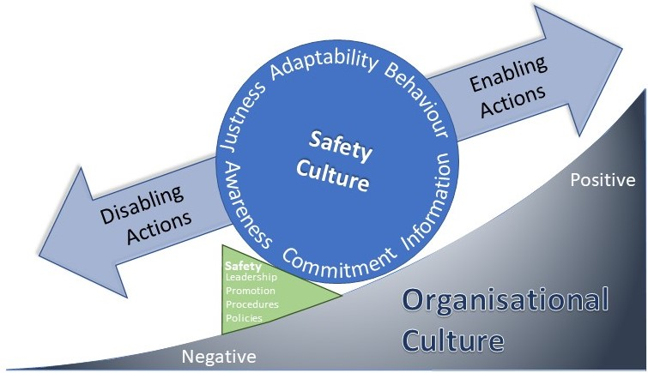
- Closed-loop investigations

Indicators of an Unhealthy SMS
- Overly difficult and not tailored
- Compartmentalized or siloed
- Compliance only mindset, lack of proactivity
- Focusses on Knowledge & Skills (superficial)
- Antagonistic or combative mindset
- Under resourced
- Inadequately documented / lack of processes
- Superficial investigations
RESOURCES
- Punitive post-incident actions
- Change management lacking risk-basis/focus
- Unrealistic or meaningless goals & objectives

Attributes, both positive and negative that influence human-performance are generally as applicable whichever side of the Regulatory-divide you may reside.

SAFETY
S M S
MANAGEMENT
SYSTEMS
SYSTEMS
EFFECTIVE
SAFETY
MANAGEMENT
March 2021
ATTITUDES
BEHAVIOURS
FOR
AND
The overarching goal of effectively managing safety is common to everyone.
Accordingly, the attributes below are as applicable to industry participants and Regulatory Authorities:

Regulator & Industry Attributes
- Adaptable and flexible mindset
- Participants trust & respect the system
- Encourages reporting
- Sees compliance as a step to effectiveness
- Open, respectful & fulsome communication
- Embraces and advocates ‘Just Culture’
- Safety seen as an investment not just a cost
- Encourages sharing of information
- Risk-based decision making
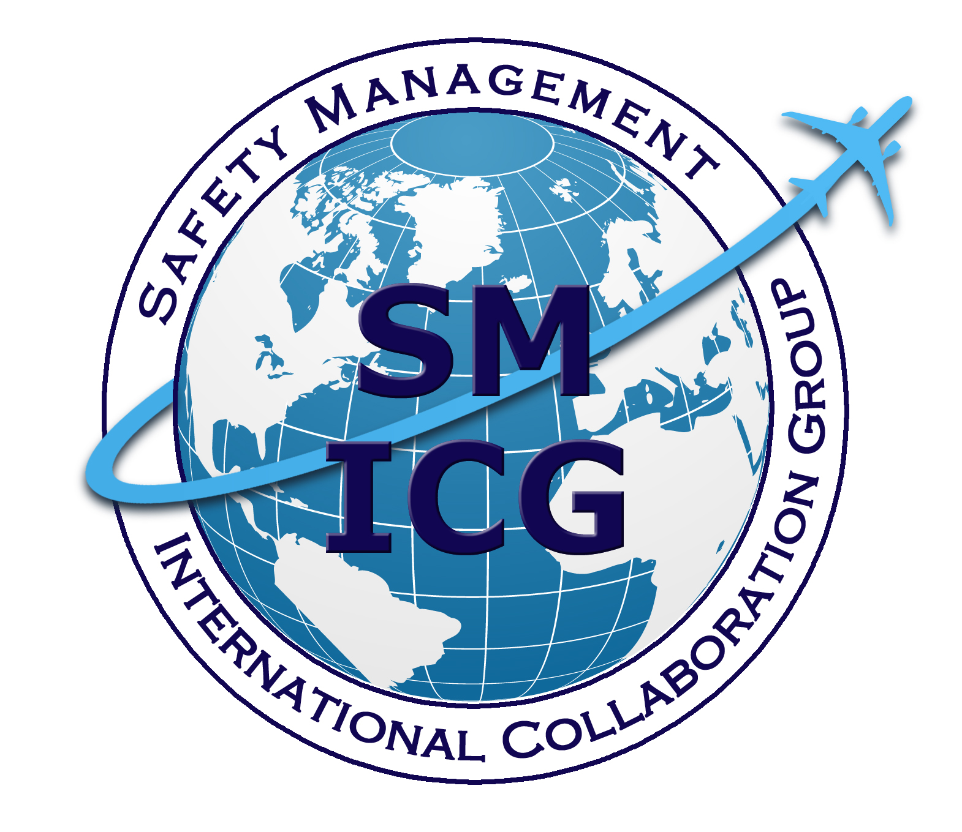

Safety Management International Collaboration Group (SM ICG) Home-page (SKYbrary)
https://www.skybrary.aero/index.php/Safety_Management_
International_Collaboration_Group_(SM_ICG)

Safety Culture for Effective Safety Management
https://www.skybrary.aero/bookshelf/books/4094.pdf

ICAO Safety Management web page
https://www.icao.int/safety/SafetyManagement/Pages/default.aspx

ICAO Safety Management Implementation website
https://www.unitingaviation.com/publications/
safetymanagementimplementation/content/#/

May 2017

http://bit.ly/SMICG

What is a Safety Management System (SMS)?
An SMS is an organized approach to managing safety. It sets out the organisation's structure, identifies the safety accountabilities & responsibilities of relevant key staff members and documents the policies and procedures to manage safety effectively.
An effective SMS allows the hazards and risks that could affect your organisation to be identified, assessed and prioritized so that appropriate mitigation measures can be put in place to reduce the risk sufficiently. Put simply:

- Actively look for safety issues in your operations, products, or services;
- Develop corrective actions to reduce the risks those safety issues present; and
- Monitor to be sure that you have appropriately controlled those risks.
E F F E C T I V E C O M P L I C A T E D

Globally, ICAO sets the standard for aviation safety management, hence each ICAO member State then ensures its operators implement an acceptable safety management system; covering:

Safety Policy and Objectives
- Management commitment & responsibility
- Safety accountabilities
- Appointment of key staff members
- Emergency response planning
- SMS documentation
Safety Risk Management
- Hazard identification
- Risk assessment and mitigation
Safety Assurance
- Safety performance monitoring and measurement
- Management of change
- Continuous improvement
Safety Promotion
- Training and education
- Safety communication
Positive Individual Attributes
- Approachable
- Adaptable
- Competent
- Accountable
- Honest
- Leadership
- Committed
- Courageous
- Inspirational
- Transparent
- Open-minded
- Integrity
- Listening

Negative Individual Attributes
- Disingenuous
- Narrow minded/closed to differing perspectives
- Focused (simply) on compliance
- Superficial
- Isolated or unapproachable

- Pre-occupied with performance indicators
ATTITUDES
BEHAVIOURS
SKILLS
KNOWLEDGE
- Complacent
- Rigid and inflexible
- Judgmental
- Punitive

A positive safety culture is a fundamental component of a healthy SMS. It is shaped by the safety attitudes, beliefs, behaviours, and values of employees in an organisation.
“Positive safety cultures and proactive safety systems work hand-in-hand, just as negative safety cultures are cause and consequence of reactive safety systems.”

Safety Culture can have a direct impact on safe performance. As such, it is critical to encourage the attitudes and behaviours that underpin a positive safety culture.

The following are ways that organisations can consistently operate safely. These are important to both the safety culture and safety performance of an organisation.
Preoccupation with failure: Continuously looking for the subtle signs of trouble.
Looking for practical drift: Understanding the realities of front-line activities; ‘work as designed’ compared to the reality of ‘work as done.’
Deference to expertise: It is important to value the input from front line staff who interact with the system every day.
Commitment to resilience: Undesired and unexpected things will occur. How an organisation responds to them is part of the continuous improvement element of a Safety Management System (SMS) and a learning culture.

