
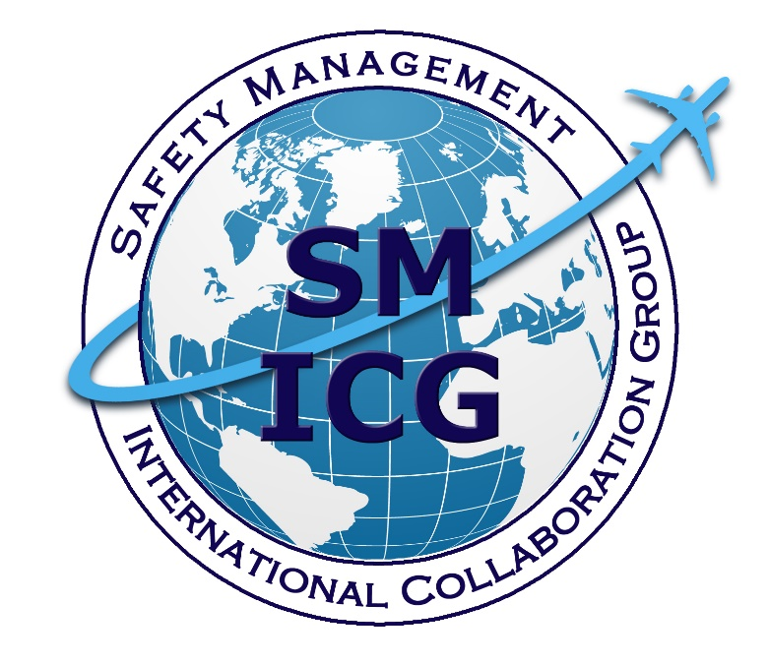
Sector Safety Risk Profiling at the State Level
May 2020
This paper was prepared by the Safety Management International Collaboration Group (SM ICG). The purpose of the SM ICG is to promote a common understanding of Safety Management System (SMS)/State Safety Program (SSP) principles and requirements, facilitating their application across the international aviation community. In this document, the term “organization” refers to a product or service provider, operator, business, and company, as well as aviation industry organizations; and the term “authority” refers to the regulator authority, Civil Aviation Authority (CAA), National Aviation Authority (NAA), and any other relevant government agency or entity with oversight responsibility.
The current core membership of the SM ICG includes the Aviation Safety and Security Agency (AESA) of Spain, the National Civil Aviation Agency (ANAC) of Brazil, the Civil Aviation Authority of the Netherlands (CAA NL), the Civil Aviation Authority of New Zealand (CAA NZ), the Civil Aviation Authority of Singapore (CAAS), Civil Aviation Department of Hong Kong (CAD HK), the Civil Aviation Safety Authority (CASA) of Australia, the Direction Générale de l'Aviation Civile (DGAC) in France, the Ente Nazionale per l'Aviazione Civile (ENAC) in Italy, the European Aviation Safety Agency (EASA), the Federal Office of Civil Aviation (FOCA) of Switzerland, the Dominican Republic Civil Aviation Institute (IDAC), the Finnish Transport Safety Agency (Trafi), the Irish Aviation Authority (IAA), Japan Civil Aviation Bureau (JCAB), the United States Federal Aviation Administration (FAA) Aviation Safety Organization, Transport Canada Civil Aviation (TCCA), United Arab Emirates General Civil Aviation Authority (UAE GCAA), and the Civil Aviation Authority of United Kingdom (UK CAA). Additionally, the International Civil Aviation Organization (ICAO) is an observer to this group.
Members of the SM ICG:
- Collaborate on common SMS/SSP topics of interest
- Share lessons learned
- Encourage the progression of a harmonized SMS/SSP
- Share products with the aviation community
- Collaborate with international organizations such as ICAO and civil aviation authorities that have implemented or are implementing SMS and SSP
For further information regarding the SM ICG please contact:
Claudio Trevisan Andrew Larsen Eugene Huang
EASA TCCA FAA, Aviation Safety
+49 221 89990 6019 (613) 993-9158 (202) 267-7577
claudio.trevisan@easa.europa.eu andrew.larsen@tc.gc.ca eugene.huang@faa.gov
Neverton Alves de Novais Charles Galea
ANAC CASA
+55 61 3314 4606 + 07 3144 7487
Neverton.Novais@anac.gov.br Charles.Galea@casa.gov.au
SM ICG products can be found on SKYbrary at: http://bit.ly/SMICG

Table of Contents
Executive Summary 2
1 Introduction 3
1.1 Sectors 3
1.2 Sector Risk Profiles (SRPs) 3
2 Sector Risk Profile (SRP) Development 4
2.1 Sector Risk Profile (SRP) Process 4
2.2 Participant Engagement and Communication 5
2.3 Establishing Sector Context 6
2.4 Identify and Analyze the Risks 7
2.5 Evaluate and Control Risks 8
2.6 Monitor Sector Safety Performance 8
3 Sector Risk Profile (SRP) Documentation and Publication 9
3.1 Sector Risk Profile (SRP) Report Examples 9

Executive Summary
Due to the growing complexity of the aviation industry, new approaches should be considered for identifying, understanding, and managing risks across all elements of the aviation system. Regulators have traditionally conducted safety oversight at the individual product or service provider level or across very wide sectors of the aviation community, such as “commercial operations” or “general aviation.” This approach can limit the ability to provide risk information that may be inherent in, and cross into, other product or service provider operations. Identifying sectors in the State’s aviation system helps regulators and service providers identify and manage risks inherent in the sector and also provides insight into risks that may exist elsewhere in the system.
A safety sector is a subset of the aviation industry that shares similar characteristics. A sector may consist of a group of related aviation products, services, organizations, or activities that may be, but are not restricted to, certain rule parts or certificate types. A component of effective safety management is identifying and analyzing shared or common risks across all sectors. Certain sectors may have unique and self-contained safety risk, while some sectors may share the same safety risks.
To improve State safety performance, it is important to develop a more nuanced understanding of the key risks faced by aviation sectors, and to improve the effectiveness of both industry and the regulator in managing those risks. As part of managing safety performance, industry organizations and the regulator should collaborate to identify, categorize, mitigate, and monitor sector risks. Developing sector risk information from multiple product or service providers with common traits and characteristics will improve the regulator’s risk-based oversight. It will also inform product and service providers of the risks identified or experienced by others conducting similar activities.
The ultimate purpose of sector risk profiling is to support participants in managing their operation’s safety risk, thereby improving the level of safety in the aviation sector. An effective Sector Risk Profile (SRP) will also inform the State on the best areas to focus its regulatory response and resources.
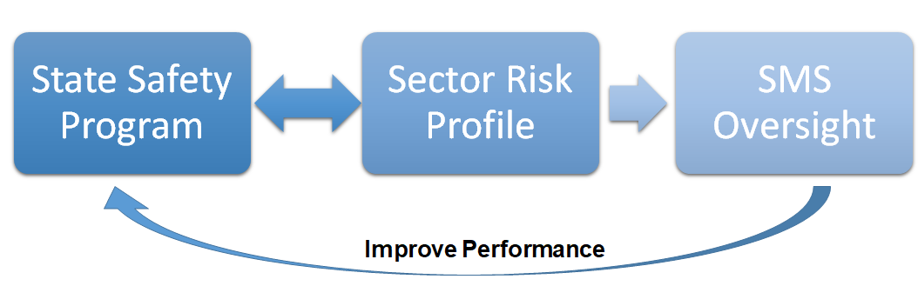
Figure 1. Sector Risk Profile Relationship to the State Safety Program and SMS Oversight
Sector risk profiling can be considered while developing, maintaining, and executing the State’s National Aviation Safety Plan (NASP) to support the management of areas of greater risk and execution of the State Safety Program (SSP). Figure 1 above shows the relationship between SMS oversight, the SSP, and SRPs.

Introduction
The purpose of this document is to provide regulatory authorities and service providers with guidance to develop and publish a Sector Risk Profile (SRP). The regulatory authority will initiate and facilitate the SRP development process, in collaboration with relevant regulatory and non-regulatory participants.
Sector-specific SRPs are developed by describing the characteristics of that sector in terms of exposure to hazards and estimating the related risks within that sector.
When fully developed, the SRP will provide the regulator and participants with consistent key safety risks for the sector, which can in turn be integrated into the sector service providers’ Safety Management System (SMS).

Sectors
A sector is a group of related aviation services, organizations, activities, or products that have similar characteristics or common features. A number of factors may be considered when identifying a candidate sector, including but not limited to:
- Type of operation/activity (e.g., commercial; agriculture; helicopter; air traffic control [ATC]; maintenance, repair, and overhaul [MRO]; design; manufacturing; etc.);
- Type of aircraft (e.g., large transport, helicopters, etc.);
- Emerging risks (e.g., new technology, remotely piloted aircraft systems
[RPAS]); and
- Any other aviation entities or activities that share related traits or characteristics that may benefit from assessment of common or shared risks.
Some examples of sectors are: helicopter tour operations, livestock mustering, agricultural operations, air ambulance services, small airplane operations, aerodromes, sport and recreational activities, flight training, etc.

Sector Risk Profiles (SRPs)
An SRP contains a description of the risks that may affect a group of related aviation products, services, organizations, or activities. These risks are required to be managed in the context of the SSP and service provider SMSs. Members of a sector may be exposed to similar operating conditions and as such may be exposed to similar risks. Therefore, the risks identified in a sector should be considered by all members in that sector.
SRPs use quantitative and qualitative methods to capture the knowledge, experience, and perceptions of as many participants as possible within a particular sector. This results in the identification of key safety risks that are relevant to that sector.
There are several ways an SRP can be used by industry participants and the regulator. For example, an SRP may help inform the regulatory authority where to target its actions and resources.
A key benefit of an SRP is achieved when both regulators and service providers collaboratively assess risks, determine which risks apply, and then implement actions to mitigate those risks.
By effectively assessing and addressing risk within a sector, the overall accident rate and costs to the sector can be reduced.

Sector Risk Profile (SRP) Development

Sector Risk Profile (SRP) Process
It is not the purpose of this document to instruct the reader on the detailed processes of risk identification and management; the principles of that activity can be found in external references and are not repeated here. However, this document does include discussion on establishing the sector context, sector objectives, sector engagement, and SRP documentation, as those parts of the process are specific to the SRP process at the regulatory authority level.
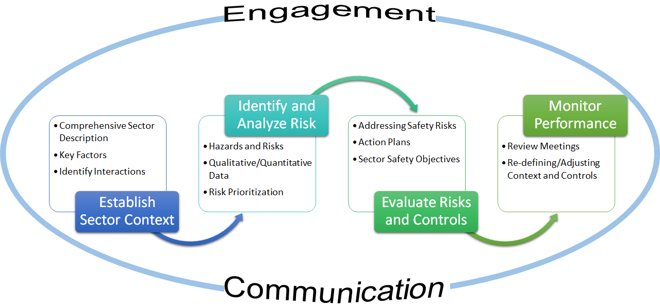
Figure 2. Sector Risk Profile Process
The basic process, depicted in Figure 2 above, is as follows:
- Establish the sector context
  - Identify shared or common attributes that constitute a sufficient base of interest to convene and sustain follow-on activities by and on behalf of the affected aviation system participants
- Identify and analyze risk
  - Gather data from as many sources as possible, including accident/incident data, operational trend data, surveys, and local and international safety information
  - Workshop with participants to define risks and contributing factors
- Evaluate risks and controls
  - Refine risk statements, evaluate existing risk controls, and develop potential risk controls
  - Develop controls for minimizing the likelihood, the consequences, or both
- Monitor performance
  - Publish the SRP, which will include risks and associated controls, ownership of the controls, a timeline, and an action plan
  - Monitor and review control effectiveness, and update controls and remaining sector risks appropriately.

Participant Engagement and Communication
A critical element in establishing an effective SRP is the active participation and engagement of sector participants. Although participation is voluntary, those initiating the development of an SRP are best served by creating an open and objective environment for participation, input, and action by sector representatives. Soliciting participant involvement adds information and data from varying perspectives in the sector and maximizes the likelihood of a comprehensive SRP.
Participants in an SRP are those organizations, entities, agencies, persons, etc., that have an interest in the activities of the sector, are affected by the safety risks, or can influence the safety performance of the sector. Sector organizations and relevant sector participants should be invited and encouraged to participate and contribute at all stages of the SRP process.
Care should be taken to assemble a manageable sized group of participants, based on their ability to make a valuable contribution. Therefore, it is important to identify and select the participants, by asking and determining:
- What is their experience in the sector?
- Who are they? What can they contribute?
- What do they want? What is their interest?
- What influence do they have?
- What is the best way to involve them?
- What is their ability to take part in the SRP process (time, expertise, etc.)?
This approach must be systematic and open-minded and should include consideration of non-aviation stakeholders. This addresses the dynamic nature of aviation where disruptive or new technologies and business models are challenging the way that aviation has been regulated and how the problems of the sector are identified and assessed.
Workshops are recommended to facilitate effective engagement and involve industry, regulatory, and other relevant participants. The following steps may be useful:
- Focus on identifying and prioritizing sector risks based on safety data from operations, manufacturer’s maintenance organizations, regulators, international, or other credible sources.
- Include a wider stakeholder group (e.g., airworthiness, ATC, airports, meteorology, etc.) to determine the causes and contributing factors of these risks.
It may be useful to host these workshops on more than one occasion during the development of an SRP. For example, the first workshop may identify hazards and risks. Once those hazards and risks are collated, a second workshop may be held to determine contributing factors, controls, and mitigations.
The regulatory authority should take responsibility for the collection and collation of data and the refinement of information for use in the workshops.
As the SRP is developed, finalized, and executed, those leading the work should:
- Ensure the interests of sector participants are considered and understood;
- Establish the context appropriately and define the scope of the SRP work;
- Reconfirm the stakeholder group and SRP participants, providing opportunities for new members to join at different stages;
- Confirm the relevance and accuracy of the information used; and
- Ensure different views are appropriately considered.
In summary, communication, transparency, and consultation with sector participants are critical because they provide input and decision-making context about risks, causes, and actions based on their perceptions and experiences in the sector. An effective SRP cannot be defined without proper engagement with key participants. States must be thorough in consulting with the most appropriate participants in developing and monitoring an SRP.
Note: The Safety Management International Collaboration Group (SM ICG) developed a document entitled Guidance for Comprehensive Safety Performance Management in a State Safety Programme (hereafter referred to as “SPM Doc”), containing detailed guidance on hazard identification, risk analysis, risk treatment, control monitoring, and assessing safety performance. These elements of safety management, although articulated at the State level in the SPM Doc, can be scaled for consideration at the sector level.
For more information, refer to the following section in the SM ICG SPM Doc:
- SPM Doc Section 8.1, Designate Responsibilities and Establish Teams

Establishing Sector Context
The sector context provides a comprehensive description of the sector and identifies key factors that may affect the safety performance of individuals and/or organizations within a sector. The sector context should identify the interactions between all participants involved, and specify how these interactions may affect the identification of risks and the measures taken to mitigate those risks.
The following are examples of key factors that may be included as part of the sector context:
- Types of operation
- Scope (i.e., how large is the sector)
- Cultural, political, geographical, and social environment
- Economical/financial/competitive issues
- Legal and regulatory framework
- Technological level
- Safety culture
- SMS maturity of the organizations
- Relationships amongst participants
In addition to sector information and key factors, the sector context also supports the identification of the sector safety objectives (refer to Section 2.5, Evaluate and Control Risks below) and the identification of information/data for the sector as defined in the following sections.
To ensure risk profile accuracy, the sector context should be regularly reviewed and updated as information and/or factors change.

Identify and Analyze the Risks
Sector hazards should be identified along with estimates of their corresponding severity and likelihood using a combination of the available quantitative and qualitative data in conjunction with the judgement of sector participants from industry and the regulator.
Expert opinion should be validated using objective quantitative and/or qualitative safety data to the greatest extent possible; there should be a good representation from all stakeholders.
- Industry experts have knowledge of safety data, safety issues, analysis of these issues, and deficiencies of barriers at the level of an organization within their sector.
- Regulatory authority experts are involved in the analysis of safety data (mandatory and voluntary occurrence reports, safety performance indicators, accidents/incidents reports, etc.), as well as the oversight of the industry.
Severity and likelihood information may be assessed in a risk matrix to promote common understanding of risks in the sector.
Once all risks have been assessed, they should be prioritized and captured in an action plan.
For more information, refer to the following sections in the SM ICG SPM Doc:
- SPM Doc Section 4.1, Starting with a Clear Risk Picture
- SPM Doc Section 5.1, Developing a Risk Picture
- SPM Doc Section 7.2, Analyzing Operational Safety Issues

Evaluate and Control Risks
In order to establish clear sector safety objectives, it is important to first follow the framework in the SPM Doc to develop a clear risk assessment program that reflects the most significant risks in the sector.
Sector safety objectives should be clearly defined in order to communicate safety priorities to sector participants. Objectives should also provide all relevant sector participants with direction on how to address the sector’s key safety risks through effective allocation of resources. Sector objectives should contain information showing how the actions taken to control sector risk (taking into account the operational context) align with higher level State safety objectives.
In order to achieve the sector safety objectives, sector participants should collaboratively design an action plan, describing risk controls to be completed by each organization involved. Responsibility and schedule for each action should be identified, and include indicators or measures that verify the actions taken are having the intended effects.
Participants should consider creating a sector “Risk Register” (examples from Australia and New Zealand are listed in Section 3.1, Sector Risk Profile [SRP] Report Examples). A Risk Register is a summary of the top sector risks, risk owners, risk treatments, status updates, etc., and has been shown to be a useful tool to convey important information.
Refer to the following sections in the SM ICG SPM Doc:
- SPM Doc Section 4.2, Establishing Safety Objectives
- SPM Doc Section 5.2, Defining State Safety Objectives
- SPM Doc Section 8.6, Defining SPIs and Their Specifications

Monitor Sector Safety Performance
The sector participants or a representative management team should hold periodic review meetings to verify that the plan to mitigate sector risks is proceeding as intended; adjust controls that are not meeting expectations; and discuss any emerging sector risks that should be considered. This should be accomplished with data and expert opinion.
The SRP review meeting should consider questions such as:
- Are the right safety issues being addressed?
- Should the risk controls be adjusted, added, or dropped in response to changes in the sector risk picture or safety objectives?
- Are the mitigation strategies effective?
- Are there any other changes that have an impact on the risks or the monitoring plan?
- Are sector participants implementing risk controls as expected?
- Are the timelines to achieve the targets being met?
- What is the outcome of the SMS oversight?
- Are there any changes to State safety objectives that could impact the SRP?
Periodic reviews by the sector participants should be performed to help identify when specific safety issues are no longer a problem, allow adjustment of ongoing risk controls, and provide additional focus in areas that need more attention. Plan updates made as a result of these reviews should be reflected in the SRP Risk Register and action plan.
For more information, refer to the following sections in the SM ICG SPM Doc:
- SPM Doc Section 9.1, Determining the AloSP to Be Achieved
- SPM Doc Section 9.2, Analyzing Information
- SPM Doc Section 9.3, Review Process

Sector Risk Profile (SRP) Documentation and Publication
The following are recommendations on content structure for an SRP report:
- Brief explanation of what an SRP is and the methodology used to develop the report
  - This can aid in the reader’s understanding of the context in which the sector risks were determined, and thereby increase confidence in those findings.
  - Diagrams may be useful to illustrate the process.
- Definition of the sector profiled and participants within the sector
  - This will to clearly illustrate the scope of the report.
- Sector safety objectives
- Overview of data sources
- The sector risks, their respective ratings, the risk owners, and current defenses and mitigations
  - This could be shown as a Sector Risk Register, which documents risks, actions, timelines and residual risk after control implementation.
- Advice on how to use the findings of the report, noting that the greatest value of an SRP is derived when participants, including the regulatory authority, read the risk statements, decide which ones apply to their organization and then determine what they can do to minimize that risk.
The SRP report is then circulated to all participants participating in the process.
The SRP should be reviewed and updated periodically to ensure that the context in which it has been developed remains current, the identified key risks remain relevant, the applied risk controls are effective, and that emerging risks are properly considered.

Sector Risk Profile (SRP) Report Examples
Examples of previously completed reports can be found at the following addresses:
- Civil Aviation Authority of New Zealand
  - SRP Medium and Large Aircraft Air Transport Sector
    - See also the associated Risks and Proposed Actions - Implementation Plan
  - SRP Part 135 Helicopter and Small Aeroplane Operations
    - See also the associated Risks and Proposed Actions - Implementation Plan
- Civil Aviation Safety Authority of Australia
  - Sector Safety Risk Profiles

SM ICG Product, Guidance for Comprehensive Safety Performance Management in a State Safety Programme, published in July 2019, https://www.skybrary.aero/index.php/Guidance_for_Comprehensive_Safety_Performance_Management_in_an_SSP
SM ICG Product, Guidance for Comprehensive Safety Performance Management in a State Safety Programme, published in July 2019, https://www.skybrary.aero/index.php/Guidance_for_Comprehensive_Safety_Performance_Management_in_an_SSP

