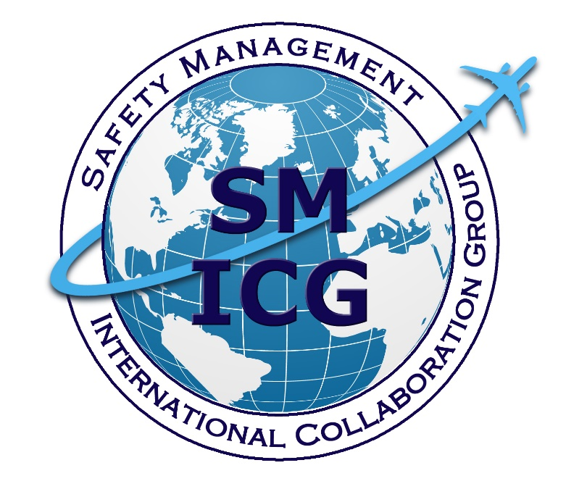

November 2022
The Safety Manager’s Role in Safety Management Systems
This paper was prepared by the Safety Management International Collaboration Group (SM ICG). The purpose of the SM ICG is to promote a common understanding of Safety Management System (SMS) / State Safety Programme (SSP) principles and requirements, facilitating their application across the international aviation community. In this document, the term “organization” refers to a product or service provider, operator, business, and company, as well as aviation industry organizations; and the term “authority” refers to the regulator authority, Civil Aviation Authority (CAA), National Aviation Authority (NAA), and any other relevant government agency or entity with oversight responsibility.
The current core membership of the SM ICG includes the Aviation Safety and Security Agency (AESA) of Spain, the National Civil Aviation Agency (ANAC) of Brazil, the Civil Aviation Authority of the Netherlands (CAA NL), the Civil Aviation Authority of New Zealand (CAA NZ), the Civil Aviation Authority of Singapore (CAAS), Civil Aviation Department of Hong Kong (CAD HK), the Civil Aviation Safety Authority (CASA) of Australia, the Direction Générale de l'Aviation Civile (DGAC) in France, the Ente Nazionale per l'Aviazione Civile (ENAC) in Italy, the European Aviation Safety Agency (EASA), the Federal Office of Civil Aviation (FOCA) of Switzerland, the Dominican Republic Civil Aviation Institute (IDAC), the Finnish Transport and Communications Agency (TRAFICOM), the Irish Aviation Authority (IAA), Japan Civil Aviation Bureau (JCAB), the United States Federal Aviation Administration (FAA) Aviation Safety Organization, Transport Canada Civil Aviation (TCCA), United Arab Emirates General Civil Aviation Authority (UAE GCAA), and the Civil Aviation Authority of United Kingdom (UK CAA). Additionally, the International Civil Aviation Organization (ICAO) is an observer to this group.
Members of the SM ICG:
- Collaborate on common SMS/SSP topics of interest
- Share lessons learned
- Encourage the progression of a harmonized SMS/SSP
- Share products with the aviation community
- Collaborate with international organizations such as ICAO and civil aviation authorities that have implemented or are implementing SMS and SSP
For further information regarding the SM ICG please contact:
Bernard Bourdon Andrew Larsen Eugene Huang
EASA TCCA FAA, Aviation Safety
+49 221 89990 2022 +1-343-551-1446 (202) 267-7577
bernard.bourdon@easa.europa.eu andrew.larsen@tc.gc.ca eugene.huang@faa.gov

Neverton Alves de Novais Adrian Duncan Nick Leow
ANAC CAA NZ CAAS
+55 61 3314 4606 +64 0 4 560 9608 +65 6541 3046
Neverton.Novais@anac.gov.br adrian.duncan@caa.govt.nz Nick_LEOW@caas.gov.sg

SM ICG products can be found on SKYbrary at http://bit.ly/SM ICG.

Table of Contents
1. Introduction 1
2. Safety Manager in the Context of Safety Management: Overall Picture 1
2.1. The Safety Managers’ Standing within an Organization 2
2.2. Scalability 2
3. The Roles and Responsibilities of a Safety Manager 2
3.1. Roles 2
3.2. Responsibilities 3
4. Knowledge, Skills, and Attitudes Valuable for a Safety Manager 5
4.1. Knowledge 5
4.2. Skills 5
4.3. Attitudes and Values 6
4.4. Safety Manager Training 7
4.5. Confirmation of a Safety Manager’s Appointment 7
5. Flexibility and Scalability Considerations 8
Appendix A: Competency Requirements of a Safety Manager A-1

Introduction
The objective of this document is to provide guidance on the roles and responsibilities of the Safety Manager; associated knowledge, skills, and attitudes; examples of do and don'ts; considerations on the scalability of the Safety Manager tasks based on the size and complexity of the organization; and training syllabus for consideration.
It is important not to view Safety Manager roles and responsibilities in isolation, but rather how the role should be integrated with the entire organization. In addition, it is important that any decisions made with regards to the role of the Safety Manager do not compromise the responsibilities held by other managers. Finally, it is also important to consider that, depending on the size and complexity of the organization, these roles and responsibilities may vary from one organization to another.
This document is primarily meant for the Safety Manager; however, it is also relevant for senior management personnel and regulators seeking to better understand the roles and responsibilities of the Safety Manager in the implementation and maintenance of Safety Management Systems (SMS).
The Safety Manager, as defined by the Safety Management International Collaboration Group (SM ICG), is the responsible individual and focal point for the implementation and maintenance of an effective SMS.

Safety Manager in the Context of Safety Management: Overall Picture
One of the major misconceptions is that the Safety Manager is entirely responsible for the safety of the organization. The management of safety is the responsibility of everyone within an organization, not just the Safety Manager. In particular, all managers have a role to play in the effective implementation of SMS throughout the entire organization and in leading a positive safety culture in their respective operational areas. Notably, the line business managers (also known as front line managers or line managers) are best placed to identify hazards in their domains, assess the risks, take the appropriate mitigation actions, and monitor the effectiveness of the actions as well as the performance of the operations. While the Safety Manager may identify risks at the operational level through the tracking and trending of the system as a whole, the line business managers remain responsible for monitoring the risks in their respective areas, not the Safety Manager.
When the operational safety performance is lower than expected, it is important that such situations be reported to senior management so that the appropriate resources can be allocated to address the safety issues. The resources will address the issues by setting relevant safety objectives to improve the safety performance in those areas, and accept, limit, or reject the operations during the interim phase. Such critical decisions can only be taken by senior management within the organization, ultimately the Accountable Executive.
Note: Here “senior management” can also refer to the (high-level) safety committee (or any other functional body such as a Safety Review Board [SRB]).
This is where the Safety Manager comes into the picture—interfacing and facilitating between the line business managers and senior management as well as ensuring that relevant safety information flows up and down for the effective management of safety at all levels of the organization. The Safety Manager also plays an important part in sharing safety information across organizational boundaries with relevant authorities and other organizations.
Unfortunately, several issues identified during SMS surveillance indicate that the Safety Manager role is neither well understood nor clearly defined despite the fact that it is vital to an effective SMS. Examples of these issues include: SMS implementation not performing at the expected level; Safety Managers not sufficiently competent; not understanding what an SMS is aiming to achieve; and lack of empowerment of the Safety Manager within the organization. Therefore, this document clarifies these roles and responsibilities.

The Safety Managers’ Standing within an Organization
The Safety Manager often acts as advisor, analyst, and facilitator. Safety Managers mainly coordinate and facilitate the implementation of the SMS since it is paramount that all stakeholders within the organization participate in the implementation of the SMS.
Senior management’s active leadership and commitment to the creation of an environment where effective safety management can flourish is essential. All personnel, across the entire organization, have a role to play in ensuring the right outcomes should be practically achievable, subject to the attributes of the organization (scalability). Notably, the acceptable risk level should be defined by the senior management by establishing the risk mitigations that can be justifiably engaged, considering what can reasonably and practically be achieved. In turn, this will enable Safety Managers to be successful within their functions.
It is important that organizations keep safety at the heart of their operations. To help with that, Safety Managers should maintain an appropriate degree of independence from business or operational departments so that they are not subjected to undue pressure or constraints.
Given that SMS applies to organizations as a whole, positioning the SMS Manager within the traditional hierarchical lines of responsibility is often difficult. To fulfill their duties effectively, the Safety Manager should have access to all the functions of the company, without any restriction, and to all management levels, including the Accountable Executive. Therefore, all managers, with particular regard to those responsible for operational activities of the organization (i.e., technical manager, operation manager), must ensure the maximum collaboration with the Safety Manager and avoid any conflict. The organization’s SMS manual, or other documentation, should clearly define the interrelationships between the Safety Manager and the rest of the organization as well as the power to access its highest management levels. Finally, the Safety Manager’s roles and responsibilities as well as other Manager’s roles and responsibilities (particularly safety responsibilities) should be clearly explained within the organization’s SMS documentation.
The Safety Manager is responsible for facilitating the healthy operation of the organization's SMS with the ultimate responsibility of risk acceptance to ensure the safe use of the organization's products and/or services falling to the Accountable Executive.

Scalability
As the size of the organization and complexity of the operations increases, the Safety Manager will move from a more hands-on role to a supervisory one. In small organizations with a very lean management team, the Safety Manager will typically execute most of the safety management functions. In large organizations with many line business managers, the Safety Manager will play a more supervisory and supportive role to ensure the coherence of the safety management processes throughout the organization. More details on scalability are available in Section 5.

The Roles and Responsibilities of a Safety Manager
The Safety Manager of an organization will have multiple roles and varying responsibilities depending on the size, scope, and operational realities of the organization. These roles and responsibilities will also likely evolve. The list below is not intended to capture all items, but rather provide a guide to establish a common baseline.

Roles
The range of the Safety Manager’s role and the required competencies of the person(s) within the role will depend on the size, scope, and complexity of the organization. One size is not going to fit all when it comes to the position, role, and competencies of the person fulfilling the Safety Manager function.
Regardless of the size of the organization, a typical Safety Manager has many roles. These roles are likely to include:
- An advisor for safety committees and senior management;
- An organizer and analyst of safety data and information;
- An integrator of the SMS processes and systems;
- A coordinator and communicator with various stakeholders; and
- A facilitator for training and safety information.
Often, competing company priorities associated with the marketplace, financial, staffing, growth, or other business needs can influence decisions by safety practitioners. In an ideal scenario, the Safety Manager would be entirely independent of the operational activity. This independence will allow the Safety Manager to provide impartial advice and review safety issues objectively, without fear of reprisal or discipline.
Often within very small to medium operations, the Safety Manager holds multiple roles within the company. For example, the Safety Manager may also be the chief pilot within the operation. In this scenario, organizations must maintain cognizance of objectivity and impartiality required for the Safety Manager to perform their functions effectively. For organizations that have a Safety Manager performing multiple roles, they should consider relevant and realistic options to ensure the greatest level of independence possible for the position.
The role of the Safety Manager within a larger organization may combine people management requirements to oversee the safety department as well as being a trusted advisor to senior management regarding safety data and information. In the same vein, the Safety Manager should ensure that operational departments’ safety management processes do not operate in silos. They should promote collaboration when dealing with cross-departmental safety issues and resolutions. They should also engage with the line business managers on the level of safety performance achieved by similar organizations within the sector risk profile.

Responsibilities
The Accountable Executive and senior management are responsible for developing, maintaining, and making the SMS effective. The Safety Manager focuses more on the applicability, coherence, promotion, and relevance of SMS implementation across the organization.
Therefore, one major responsibility of the Safety Manager is ensuring that the right topics with the right evidence and safety information are brought to the attention of the Safety Committee (or equivalent functional body) and/or the Accountable Executive. This is so senior management can prioritize and assign the best use of resources; make safety-based decisions; justify them; take appropriate actions; and document accordingly. The Safety Manager's responsibility is to verify that an accurate picture of the organization's risk landscape is communicated. This will ensure a constructive discussion can take place and the risks within the operations are kept as low as reasonably practicable.
The Safety Manager assists management by clarifying the SMS policies and practices for the organization, thereby facilitating the understanding of safety risks and controls. The Safety Manager should not be seen as the one responsible for managing safety throughout the organization. Some decisions have to be made at the executive level (e.g., allocating resources, financing barriers) and others have to be taken at the operational level. In no case is it incumbent upon the Safety Manager to make those decisions.
Depending on the size and the complexity of the operations, the typical Safety Manager’s responsibilities may cover:
- Maintaining safety documentation;
- Communicating across the organization so that everyone has the appropriate level of awareness and is on the same page in terms of expectations for their role and their responsibilities related to safety;
- Ensuring that everyone understands safety policies, processes, and procedures;
- Supporting operational departments and managers on the use of Safety Management processes (e.g., assisting operational personnel in conducting risk assessments according to a common risk assessment methodology and assigning effective, operationally relevant controls);
- Challenging, inspiring, mentoring, and encouraging positive employee attitudes, behaviours, and actions towards safety;
- Coaching and training staff in the use of Safety Management tools and methodologies as described in the SMS manual (or equivalent);
- Collecting, evaluating, processing, analyzing, and storing safety information from within their own organization as well as the wider aviation industry (notably within the sector risk profile);
- Providing impartial safety advice and guidance to management and staff;
- Gathering, producing, and disseminating safety information throughout the organization;
- Ensuring that proper safety training is provided so that risk assessment processes are ingrained within the organization and that safety discussions are facilitated throughout the organization;
- Fostering a positive safety culture throughout the organization; this includes promoting an open reporting culture and ensuring that punitive actions are not taken against individuals making voluntary or mandatory safety reports;
- Monitoring how the just culture policy is applied, and reporting to the Accountable Executive when issues are identified;
- Ensuring that the reporting system is effective and that occurrences have been timely and properly analyzed; in particular, ensuring that identified root cause(s) of incidents, accidents, and failures within the system are relevant and mitigated accordingly to prevent recurrence;
- Encouraging operational departments and/or individuals to take ownership of safety issues and risks;
- Ensuring consistency and coherence of safety processes across the organization;
- Ensuring that corrective and preventive actions are managed and implemented by the relevant departments; are performing as intended; and are reported to the safety committee (or other functional body);
- Supporting the organization in monitoring the implementation process to achieve the safety goals;
- Ensuring that the organization has policies, procedures, and plans for responding to emergency situations (i.e., overseeing emergency response for the organization);
- Ensuring safety issues are properly coordinated, communicated, and addressed between internal and external bodies including:
  - Third-party service providers;
  - Regulatory authorities; and
  - Investigative bodies.
- Ensuring that communication is maintained within the safety team when responsibility is delegated to other staff; ensuring they are regularly informed in all areas of the safety program including how things are being managed; remaining active and up to date within the safety program; and
- Considering internal or external factors that may result in emerging risks or require existing risk assessments to be reviewed. In particular, evaluation of risks should occur as a result of major disruptive events (e.g., many risk assessments conducted before the COVID-19 crisis were no longer valid during and after the crisis).

Knowledge, Skills, and Attitudes Valuable for a Safety Manager
The required competencies of a Safety Manager are dependent on the associated roles and responsibilities and the size, nature, and volume of activities (see Section 5) within the organization. They are also dependent on the structure of the safety management team that is tasked to oversee the implementation of SMS within the organization. It is important to note that the Safety Manager’s duties are sometimes split among several people; nevertheless, the overall responsibility still resides with the person who is nominated as the Safety Manager. A combination of related knowledge, skills, values, and attitudes will enable that person to effectively execute the role.

Knowledge
Key areas of knowledge required by the Safety Manager include:
- Safety Management principles and tools used to support the application of these concepts. For example, it would be expected that the Safety Manager has a sound understanding of risk management principles and is aware of, and able to demonstrate, the use of risk assessment methodologies.
- Applicable regulations of the Civil Aviation Authority and any other regulatory requirements under which the organization operates.
- Knowledge of the organization’s specific operating environment, understanding the context of the operation and the associated safety risks. The Safety Manager should be able to apply this knowledge within the application of the organization's SMS. This requires at least a basic knowledge of the typical aspects of the organization (i.e., in the case of an aircraft operator, those relating to the operation of an aircraft and its flight crew) but also of the economic aspects that regulate the operation of the company and even its commercial policies. This knowledge will assist the Safety Manager in ensuring that the activities of the organization always remain within the “safety space” (ref. ICAO Doc.9859 fourth ed. – see section 2.4).
 | Safety Managers should ensure that all the key personnel (i.e., themselves, their subordinates, and other safety analysts and practitioners) have the most current training and knowledge of tools, policies, and data sources for the organization.

Skills
Skills relate to the ability to perform an activity or task. They include the application of knowledge. Proficiency in the execution of skills requires training and practice. Typically, a person acquires the knowledge of how to perform a task and then begins to perform the task. For example, one would learn the concepts and steps involved in conducting a safety assessment (knowledge), and then perform and document it (skill).
 | Don’t ignore training for safety employees! Methods, policies, tools, data sources, and organizational SMS maturity are always evolving. Keeping the safety organization up to date on these elements maximizes the value of safety work being done.
The Safety Manager is required to have a set of skills to fulfill the roles and responsibilities. The Safety Manager must:
- Be able to utilize and apply analytical and critical thinking; be able to apply knowledge to the day-to-day duties, from a systems thinking perspective; and
- Have excellent engagement and communication skills, both written and oral; be able to demonstrate social and emotional intelligence, which enables the Safety Manager to work and interact effectively within an organization.
  - The Safety Manager must be approachable and easy to engage. The Safety Manager must be able to discuss and deliver safety messages and information across all levels of the organization. Employees need to feel comfortable approaching and raising safety concerns to the Safety Manager without fear of retribution or blame.
  - The Safety Manager must work to build relationships based on trust to achieve the best safety outcomes and to help foster and build a strong organizational safety culture in which trust plays a large role. The Safety Manager must remain objective, impartial, fair, and ethical in the actions they undertake. At times, the Safety Manager will need to demonstrate tenacity and patience while negotiating challenging situations.
  - The Safety Manager must exercise judgement and tactfulness. This is particularly relevant when assigning individual or operational departments responsibilities to address safety issues.
  - The Safety Manager needs managerial and leadership skills.

Attitudes and Values
The Safety Manager should act as a focal point and a facilitator for safety and deployment of the SMS within the organization. The Safety Manager is a role model for the organization and must demonstrate the organization’s approach and belief towards safety. Overall, the individual must be a safety advocate who demonstrates commitment, safety behaviours, and a positive attitude towards safety at all times.
The attitudes and behaviours demonstrated by the Safety Manager can help foster a positive safety culture within the organization and achieve positive safety outcomes. The Safety Manager should refrain from a punitive or blaming approach while investigating safety issues unless willful misconduct or gross negligence is apparent.
Safety Manager “DOs”
- Remain open/accessible
- Remain alert to any signal of safety erosion
- Stay independent (unbiased) and fair when advice on safety matters is needed
- Be able to coordinate and communicate across the organization
- Be able to listen and be people-oriented
- Lead, inspire, encourage (e.g., show enthusiasm)
- Be assertive and challenge/encourage employee critical thinking
- Be supportive to everyone
- Instruct, train, and guide on SMS

Safety Manager “DON’Ts”
- Be the owner of the risks
- Work in isolation
- Be entirely responsible for safety
- Be complacent

In summary:
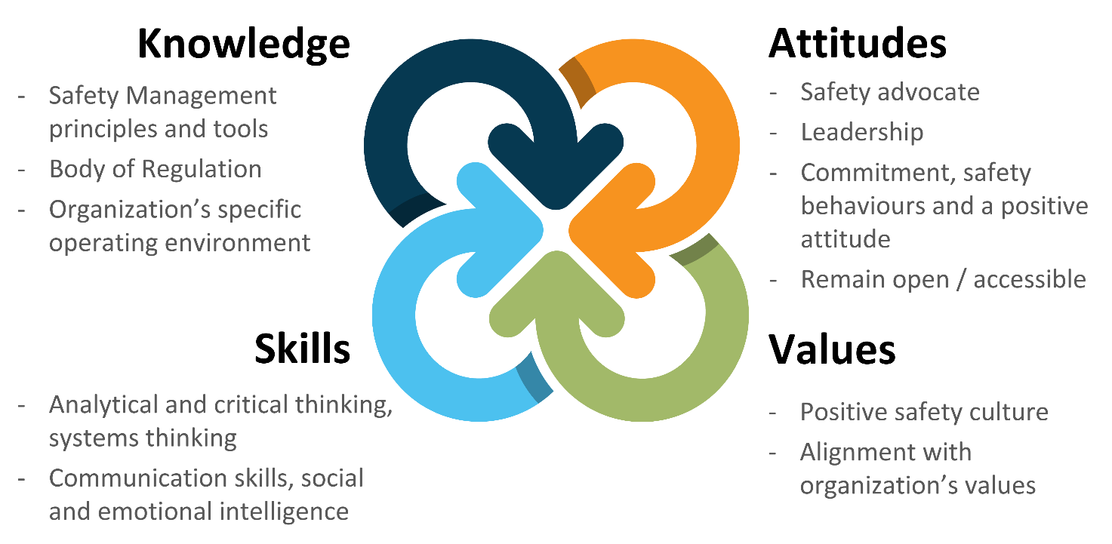

Safety Manager Training
Training for the Safety Manager in the principles of management and administration of the SMS may be undertaken in several different ways to gain formal knowledge of the subject. Depending on the size, scope, and complexity of the organization, this training may be a formal degree, classroom style short course, online training, on-the-job training, or any combination of these. The style of training undertaken needs to be commensurate with the scale of the operation. The organization needs to assess the minimum knowledge and skills that will make the Safety Manager effective for their role in the scope of the organization.
Formal training assists with giving individuals the knowledge and skills to fulfill their functions as the Safety Manager.
Organizations should ensure they maintain a training file for all personnel including the Safety Manager. This training folder should detail the individuals training and qualification history, in addition to recurrent training.
Safety Managers must ensure they complete on-going recurrent training to remain up to date in emerging methodologies and themes. This recurrence training assists with retaining overall competence to fulfill the role effectively.

Confirmation of a Safety Manager’s Appointment
The regulator should verify and challenge the Safety Manager’s qualifications. This does not mean the regulator should necessarily approve the nomination of the Safety Manager. Depending on the national regulatory framework, the requirements within the State may call for a formal approval of the Safety Manager’s nomination.
The Accountable Executive has ultimate responsibility for the organization's compliance and safety. They are also responsible for hiring a Safety Manager who has adequate competence and is capable of effectively accomplishing their duties in the specific organization and environment. The Accountable Executive is also responsible for providing adequate resources and support for the Safety Manager to effectively accomplish their duties.
The regulator may find the Safety Manager’s competency and nomination questionable; however, the qualification is so variable that this could be more the Accountable Executive’s decision to challenge. Without evidence on how the SMS is effective and how the Safety Manager satisfactorily fulfills their role and responsibility, the approval of such a nomination could be a bit tricky.
Some regulators around the world let the Accountable Executive appoint the Safety Manager, then assess the effectiveness of the SMS. In case of weaknesses, the root causes should be carefully analyzed before questioning the Safety Manager’s position. For instance, it may happen that the Safety Manager may not have sufficient support from the Accountable Executive, which means the issue is not with the Safety Manager but with the commitment of the Accountable Executive.
Inspectors should verify within surveillance activities:
- The nominated person’s knowledge and understanding of risk management concepts;
- The effectiveness of the SMS training for the Safety Manager as well as the nominated persons/operational managers; and
- The competencies of all key personnel involved in the SMS activities.

Flexibility and Scalability Considerations
The scope of the Safety Manager’s role and the required competencies of the person(s) within the role will depend on the size, scope, and complexity of the organization. A Safety Manager can assume a strategic (management) or an operational (task execution) performance (at various levels) according to the size of the organization in which it works.
Large-size organizations require a more robust organizational structure, with several areas (Management/Coordinators) acting individually and together to ensure safety. In these organizations, the Safety Manager has a strategic (management) performance. The Safety Manager assumes a role as the manager of their team, and a role of coordinator and facilitator in relation to the other teams, so that there is a good performance and integration of all activities.
For example, in a large organization, the identification of hazards and assessment of risks are handled by the respective operational departments. Safety performance indicators and targets are monitored by the operations departments. In preparation for the safety committee, the role of the Safety Manager is key in ensuring that the information reported to senior management is relevant, coherent, and accurate in order to support the right decision making.
Medium-size organizations have an intermediate level of organizational structure which varies mainly depending on their time in existence, their performance, and their maturity. In these organizations, the Safety Manager plays a mixed role, merging to a greater or lesser extent the characteristics of large and small organizations. The Safety Manager may act as a manager and/or executor of tasks, according to the characteristics of the company.
Small-size organizations typically have a simple organizational structure where a single person may perform several functions, often mixing operational duties and safety-related responsibilities. In such organizations, the role of the Safety Manager is still relevant. In these instances, the Safety Manager should use suitably scaled methods to identify hazards, assess risks, and develop and monitor risk controls. For example, in a single person operation, this may be done with a simple logbook of these activities. Or, in a multiple person operation (but still considered small), this may be done with a logbook combined with voluntary reports from fellow employees along with a simple plan to document and communicate safety activities to the Accountable Executive.
It has been noted in extremely small organizations that some Accountable Executives have outsourced Safety Manager duties. They have done this by hiring a part time Safety Manager who is often not onsite and does not take part in the daily operations of the organization. Safety Managers who act in these part time roles may have a number of challenges in supporting and improving safety within the organization due to the part time nature of their position.

In all organizations, the Safety Manager is responsible for providing the Accountable Executive with safety information for the decision-making process. For this reason, the Safety Manager typically maintains an appropriate degree of independence from the operational activities of the organization to be able to give impartial advice and review issues objectively.

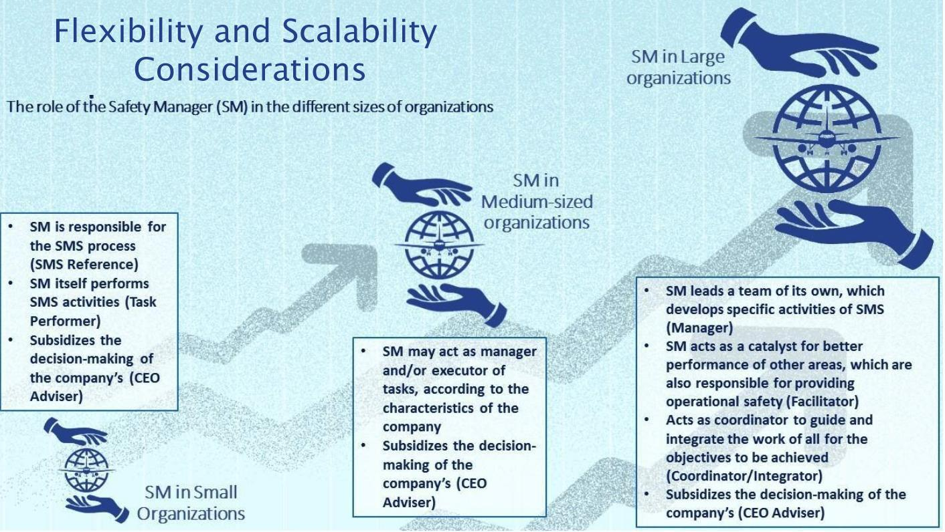

Appendix A: Competency Requirements of a Safety Manager
Safety Manager (reference CAA NZ AC100-1)
The Safety Manager is the person responsible for the development, implementation, operation, and continuous improvement of the organization’s SMS. They should act as a focal point for safety in the organization.
Typically, the Safety Manager is required to be competent and responsible for the following:
- Managing the SMS implementation plan on behalf of the chief executive;
- Facilitating the risk management process (hazard identification, risk assessment, and risk control) and ensuring cohesive implementation throughout the organization;
- Managing safety performance processes;
- Monitoring corrective and preventative actions to ensure their accomplishment;
- Maintaining safety documentation;
- Ensuring appropriate safety management training is provided;
- Providing independent advice on safety matters;
- Overseeing safety management processes;
- Ensuring the appropriate involvement in safety investigations;
- Monitoring safety concerns in the aviation industry and their perceived impact on the organization’s operations; and
- Coordinating and communicating (on behalf of the Accountable Executive) internally and externally.
In addition to the above, the Safety Manager must have an understanding of the organization’s operation and related safety critical tasks and systems, as well as competency in regard to safety management principles. Some key skills/experience should be taken into consideration to complement the professional expertise of the Safety Manager:
- Professional knowledge of the organization’s specific products, services, operations, and environment;
- Regulatory knowledge;
- Analytical thinking and problem-solving abilities;
- Inter and intra-organization project management skills;
- People-oriented skills such as objectivity, fairness etc.; and
- Communication skills, both written and oral.
The table on the following page outlines sample content of the safety training for the position of Safety Manager. The syllabus for training should take into account the complexity of the organization and the training needs analysis for the position.

Sample Content for Safety Management Training for Safety Manager
Safety Management Principles and Practices in the Aviation Environment
- The need for SMS;
- What is different about SMS;
- Relationship/integration with other management systems;
- Key principles and processes; and
- Regulatory requirements.
The Organization’s SMS, including:
- Safety policy, goals, and objective;
- Safety roles and responsibilities;
- Emergency response planning, when appropriate;
- Documentation;
- Risk management;
- Safety assurance and measurement;
- Safety reporting; and
- Safety communication and training.
Safety Risk Management Principles
- Hazard identification, risk assessment, and control
Safety Investigation Principles
Human Performance
- Human factors;
- Understanding the role of the human in safety;
- Human behaviour and performance; and
- Error management.
Safety Culture

