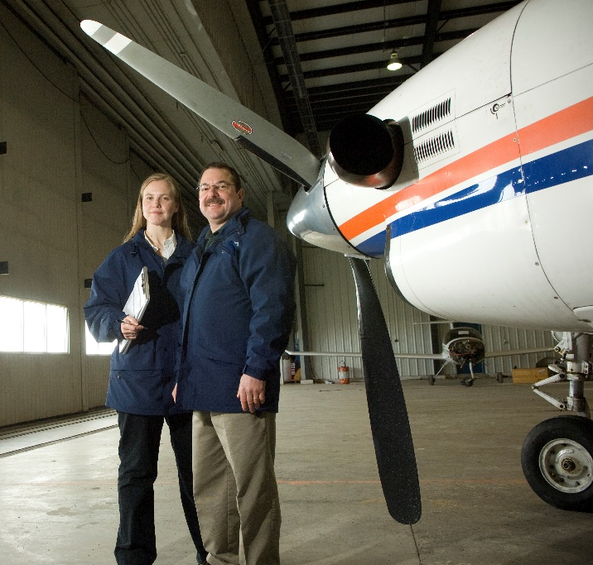

What Is a Safety Manager?

Safety Management International Collaboration Group (SM ICG)
A Safety Manager is many things: an advocate, an advisor, a coordinator, an analyst, and a facilitator. The role can be structured in different ways, but at its core, its main purpose is to have someone whose primary responsibility is to think about safety first.

A Safety Manager can be a great asset, especially for large or complex organizations with a Safety Management System (SMS).

This pamphlet covers what you need to know about the Safety Manager's Role and their responsibilities...

This pamphlet was prepared by the Safety Management International Collaboration Group (SM ICG). The purpose of the SM ICG is to promote a common understanding of Safety Management System (SMS)/State Safety Program (SSP) principles and requirements, facilitating their application across the international aviation community. In this document, the term 'organization' refers to a product or service provider, operator, business, and company as well as aviation industry organizations.

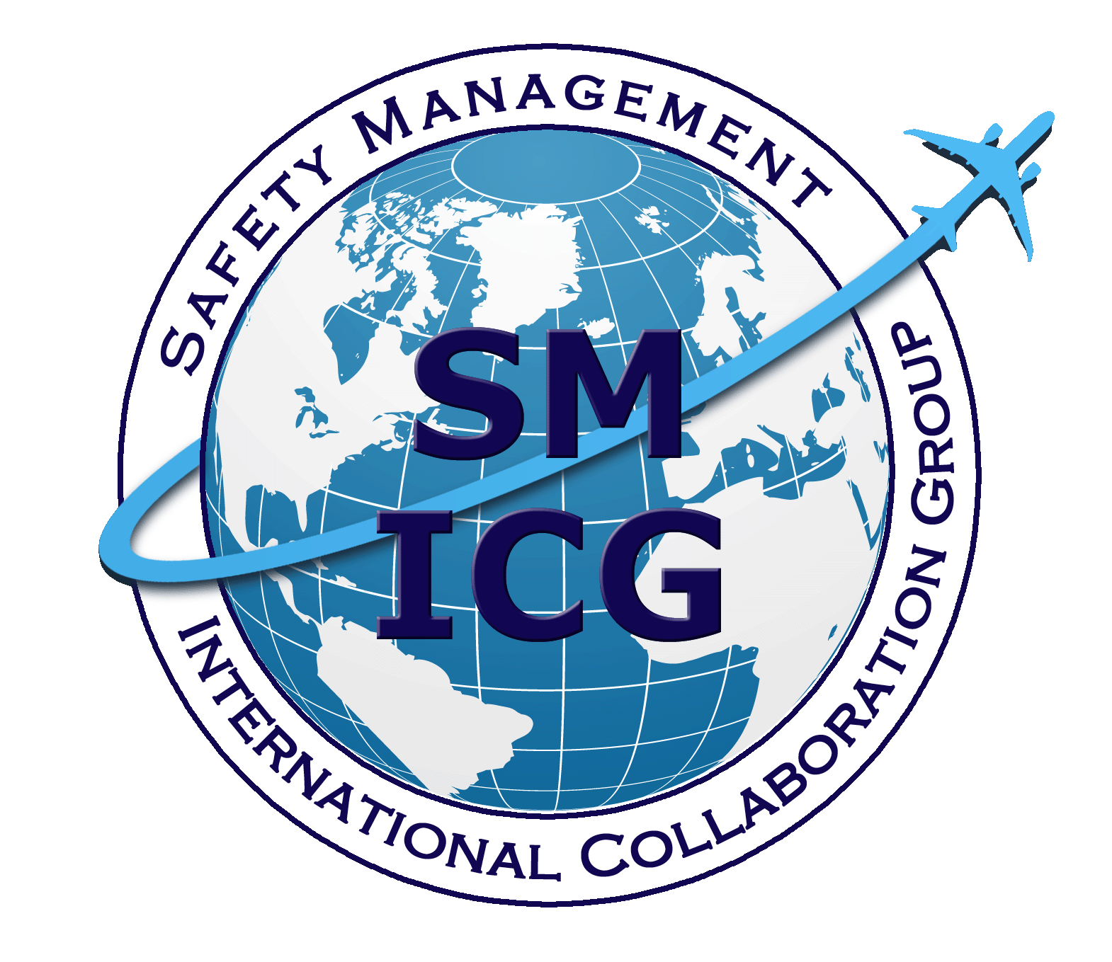
Members of the SM ICG:
- Collaborate on common SMS/SSP topics of interest
- Share lessons learned
- Encourage the progression of a harmonized SMS/SSP
- Share products with the aviation community
- Collaborate with international organizations such as ICAO and civil aviation authorities that have implemented or are implementing
SMS and SSP
SM ICG products can be found
on SKYbrary at http:bit.ly/SMICG.

Safety Management International Collaboration Group

A Safety Manager’s Role: What You Need to Know…

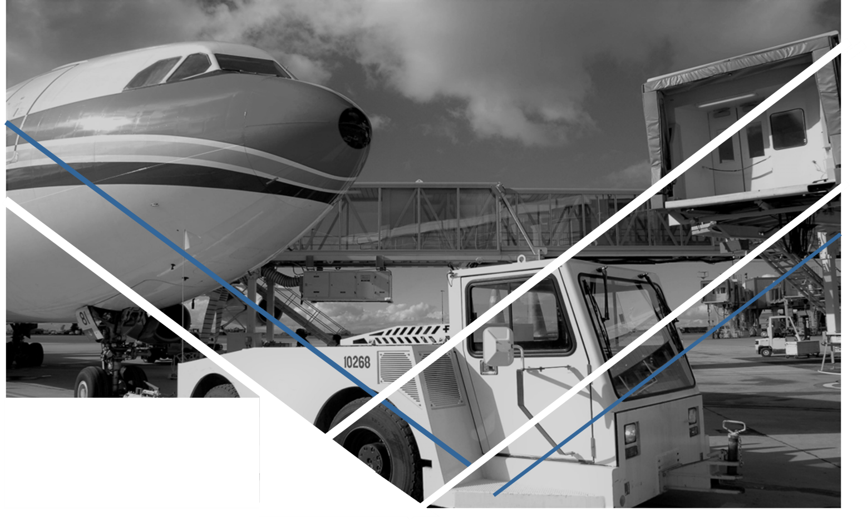
Keeping Safety in Focus…
A Safety Manager's
Role & Responsibilities:
- Provide leadership, support, and oversight of the SMS
- Maintain safety documentation and an effective reporting system
- Monitor and analyze trends in the organization's safety data
- Coordinate investigations, audits, and corrective actions; monitor the results
- Organize and/or conduct third party safety audits
- Guide the organization's risk management process
- Communicate safety information across the organization and ensure that everyone understands their roles
- Advise senior management and the Accountable Executive on safety matters
- Respond to regulatory issues
Safety is a critical element woven throughout the fabric of any aviation organization. All employees have safety responsibilities—from the Accountable Executive, to middle management, to front line workers. However, these responsibilities can sometimes be overshadowed by the immediacy of operational needs.
A Safety Manager is responsible for keeping safety goals in focus at all times. They collect, monitor, interpret, and communicate safety information from all areas of the organization.

What’s Your Risk Landscape?
What Safety Managers Shouldn’t Do:
- Set an organization's risk limits
- Allocate appropriate resources
- Hold managers accountable for safety responsibilities, performance, and implementation timelines
- Be delegated accountability for the organization's safety performance
Accountable Executives cannot delegate these responsibilities!
That safety information is then communicated to senior management so that they can make informed and risk-based decisions. For this reason, the Safety Manager should be entirely independent of the operational activity to be able to give impartial advice and review issues objectively.
The Safety Manager's role is to create an accurate picture of the organization's risk landscape and to communicate it to decision makers so that the risk to aviation safety is kept as low as is reasonably practicable.
More information about the role and responsibilities of a Safety Manager can be found on the
SM ICG SKYbrary site.

