

Need for Change Management at the State Level

Safety Management International Collaboration Group (SM ICG)
The aviation landscape is constantly evolving. Apart from overseeing changes by the service providers, Aviation Regulatory Authorities must manage changes at the organizational level that could impact the industry at large. From understanding drivers for change, the development and delivery of change strategies, to eventual implementation and communications, Aviation Regulatory Authorities have to ensure that a structured and systematic process has been utilized that involves all relevant stakeholders at the right time.

Aviation Regulatory Authorities also need to ensure effective oversight of change within the aviation system. They do this by managing change through a structured and systematic approach to support the identification and management of safety risks at the State level.
This pamphlet was prepared by the Safety Management International Collaboration Group (SM ICG). The purpose of the SM ICG is to promote a common understanding of Safety Management System (SMS)/State Safety Program (SSP) principles and requirements, facilitating their application across the international aviation community. In this document, the term 'organization' refers to a product or service provider, operator, business, and company as well as aviation industry organizations.

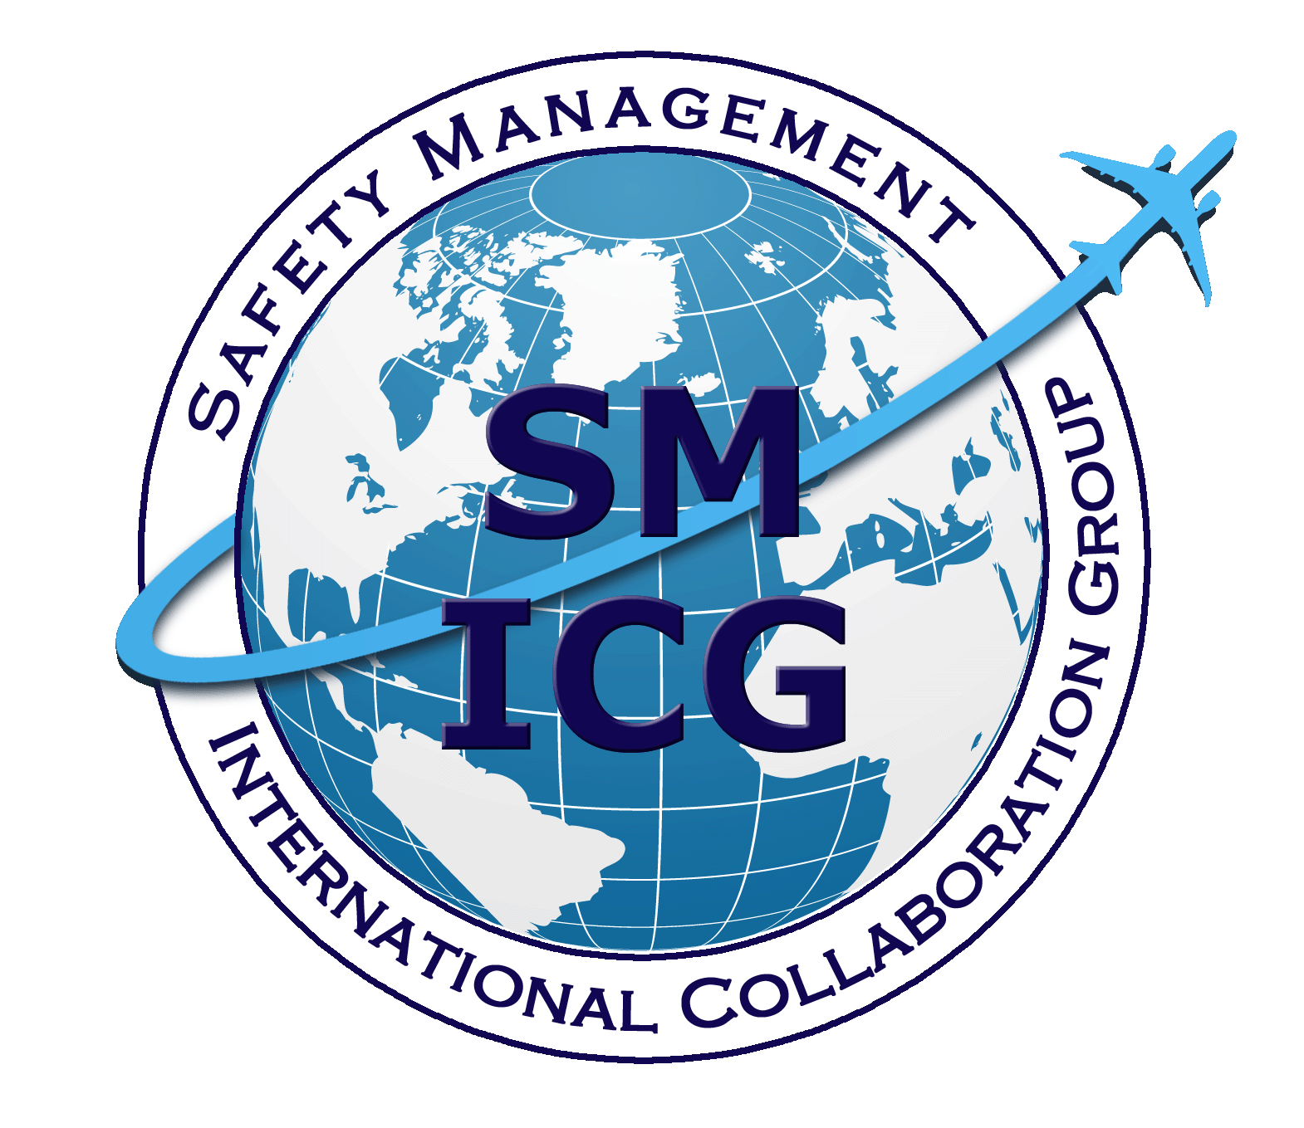
Members of the SM ICG:
- Collaborate on common SMS/SSP topics of interest
- Share lessons learned
- Encourage the progression of a harmonized SMS/SSP
- Share products with the aviation community
- Collaborate with international organizations such as ICAO and civil aviation authorities that have implemented or are implementing
SMS and SSP
SM ICG products can be found
on SKYbrary at http:bit.ly/SMICG.

Safety Management International Collaboration Group

Change Management at the State Level: What You Need to Know…


Change Management Process
Key Changes at the
State Level
There are numerous change management models and methods. Regardless of the type of changes, there is need to identify the common steps to guide the change management effort:

- Define the Change
Define why the change must occur and discern and specify the intended change to achieve the strategic objective

- Identify Key Stakeholders
Identify stakeholders who will be affected by the change, size and complexity of the impact, and roles and responsibilities in implementing changes

- Align with Relevant Plans
Assess the alignment of the change with State strategic objectives and relevant plans and take appropriate action

- Assess the Change
Assess the impact of the proposed changes on key people/organizations; identify main risks; analyze the risks and recommended mitigation strategies

Benefits of
Change Management

- Improved understanding of the changes across the organization
- High levels of awareness of context/performance
- Team cohesion and clarity
- Priorities continually well-managed
- On-going engagement loops
- Good attention to capacity building and sustainability
- Well defined outcomes and agreed upon implementable measures

- Develop and Implement an Action Plan
Develop an action plan to detail what actions, who, by when, and what resources are needed to implement the change

- Continuous Monitoring
Safety Regulatory Framework
Changes to safety regulatory framework as a result of the introduction of new or amendments to ICAO Standards and Recommended Practices (SARPs), industry feedback, or new challenges arising from new aviation developments
Organizational Change
Changes to the organization’s work environment as a result of external factors such as technology, social and political changes, or internal factors like changes in personnel, organizational structure, and deficiencies in the organization
Shift in Focus or Priority in Ensuring Safety
Changes to the aviation landscape that could introduce more risks into the aviation system and require the Aviation Authority to shift its focus or priorities to ensure safety
Develop and continually monitor key metrics, making necessary adjustments with more information

- Review the Change for Effectiveness
Assess the impact of the change; put in place a feedback mechanism to allow for periodic review
More information about change management at the State level can be found on the
SM ICG SKYbrary site.

